A Dissertation on

Reinforcement Learning Driven Hybrid Clustering for Energy Optimization in WSNs

Submitted in partial fulfillment of requirements for the Award of degree of

Master of Technology
In
Electronics and Communication
(Next Generation Wireless Technology)

Submitted By
Shubham Kumar (2448015)

Under the supervision of
Professor Bharat Gupta



Department of Electronics and Communication Engineering
National Institute Of Technology, Patna, India 800005
June 2026


राष्ट्रीय प्रौद्योगिकी संस्थान पटना
NATIONAL INSTITUTE OF TECHNOLOGY PATNA

CERTIFICATE

The undersigned certify that Shubham Kumar, Roll number 2448015, Enrolment number 240548 is registered for the M.Tech programme in Department of Electronics and Communication Engineering with specialization in Next Generation Wireless Technology under my supervision. I hereby recommend that, this Dissertation entitled, “Reinforcement Learning Driven Hybrid Clustering for Energy Optimization in WSNs” be accepted as the partial fulfillment of the requirements for evaluation and award of the M.Tech degree.

….……………………
Professor Bharat Gupta
Electronics and Communication Engineering
National Institute Of Technology, Patna

DECLARATION AND COPYRIGHT TRASFER

I Shubham Kumar, Roll No. 2448015, Enrollment No. 240548 a registered candidate for postgraduate programme M.Tech under department of Electronics and Communication Engineering of National Institute of Technology Patna, declare that this is my own original work and does not contain material for which the copyright belongs to a third party and that it has not been presented and will not be presented to any other University/ Institute for a similar or any other degree award.

I further confirm that for all third-party copyright material in my thesis/ dissertation (including any electronic attachments) is “blanked out” third party material from the copies of the thesis/dissertation/book/articles etc fully referenced the deleted materials and where possible, provided links(url) to electronic sources of the material.

I hereby transfer exclusive copyright for this thesis to NIT Patna. The following rights are reserved by the author:

- The right to use, free of charge, all or part of this article in future work of their own, such as books and lectures, giving reference to the original place of publication and copyright holding.
- The right to reproduce the article or thesis for their own purpose provided the copies are not offered for sale.

..….…………………………
Shubham Kumar
Roll No.: 2448015
Enrollment No: 240548
Place: ………………………
Date: ……………………….

COPYRIGHT © [2026] by NIT Patna. All rights reserved.
No part of this publication may be reproduced, distributed, or transmitted in any form or by any means, including photocopying, recording, or other electronic or mechanical methods, without the prior written permission of the publisher or author, except in the case of brief quotations used in critical or scholarly reviews and certain other non-commercial uses permitted under applicable copyright law, provided that proper acknowledgment is given.
ACKNOWLEDGEMENTS

I would like to express my sincere gratitude to my thesis advisor, Professor Bharat Gupta, Professor in the Department of Electronics and Communication Engineering, National Institute of Technology, Patna, for his continuous guidance and support throughout the course of this research. He was always approachable whenever I encountered challenges or required clarification regarding my research or writing. He consistently fostered independent thinking while offering timely guidance and constructive feedback as needed.
I would also like to extend my heartfelt thanks to Dr. Jayanta Ghosh, Head of the ECE Department and the members of the project evaluation panel for their valuable suggestions, encouragement and continuous support during the progress of this work.
I would also like to acknowledge my teachers, I am sincerely indebted to them for their valuable insights, constructive comments and thoughtful suggestions, which significantly enhanced the quality and clarity of this work.
Finally, I wish to express my deepest gratitude to my parents for their unwavering support, patience and continuous encouragement throughout my academic journey and during the research and writing of this thesis. This accomplishment would not have been possible without their constant motivation and belief in me.

DEDICATION

To my parents and teachers

ABSTRACT

Underground mining are very unpredictable space which demands continuous monitoring and early detection of hazardous conditions to make critical time sensitive decisions. In a typical underground mine, sensor nodes collect information about several important variables, including gas concentration, temperature, humidity and structural stability indicators. Communication reliability of WSNs in an underground environment is challenging due to the irregular shapes, narrow widths and length of tunnels, along with issues related to radio propagation. Additionally, replacing or recharging batteries in an underground mine is often costly or logistically difficult to do. Therefore, energy efficiency, stable communication and better network lifetime are critical design objectives. This study addresses the aforementioned challenges by including a new framework entitled Reinforcement Learning with Hybrid Clustering (RLHC), which is designed specifically for use in extreme underground environments. This new RLHC framework combines learning based methods with clustering techniques that were designed explicitly for both the limited energy present in nodes within WSNs and the geometry of the tunnels within mines. The steps taken in this environment is to identify a pool of high energy CHs (CH) by using Distributed Energy Efficient Clustering (DEEC) inspired methods, then CHs then Energy Efficient Knapsack Algorithm (EEKA) helps to maintain centrality and spatial balance among CHs and K-Means organizes compact clusters to reduce intra cluster communication overhead. On top of that a Q-learning agent continuously observes network parameters such as residual energy, cluster load and packet delivery ratio (PDR) and takes adaptive actions including CH switching, node reassignment and transmission power adjustment. Through iterative learning, the agent gradually converges towards energy efficient configurations suited for real underground mines deployments. The results of simulation based assessment indicate that the RLHC methodology promotes significant energy efficiency, network life span and better communication reliability.
Simulation results demonstrate that RLHC significantly outperforms conventional and meta heuristic based schemes, achieving up to 57% improvement in network lifetime and 33% energy savings over LEACH and DEECP, while also providing 45% longer lifetime and 16% additional energy savings compared to PSO, ACO and FCM based approaches. Furthermore, RLHC delivers substantially higher data reliability, achieving up to 240% throughput improvement over LEACH/DEECP and 50% higher throughput over PSO/ACO/FCM, along with consistently improved average PDR across all comparisons.

TABLE OF CONTENTS

Title Name Page No

Acknowledgements…………………………………………………………………………………………………………iii
Dedication………………………...…………………………………………………………………………………………….…iv
Abstract…………………………………………………………………………...…………………………………………………v
Table of contents…………………………………………………………………..……………………………………..…..vi
List of figures………………………………………………………………………………………….……………………...viii
List of tables………………………………………………………………………………………………………...………….…x
List of abbreviations………………………………………………………..……………………………………………...xi

Introduction 1
1.1 General 1
1.2 Project background 2
1.3 Need of the study 2
1.4 Scope of the study 3
1.5 Organization of thesis 4
Literature Review 5
2.1 Classical Clustering Protocols 5
2.1.1 LEACH and Its Variants 5
2.1.2 DEEC and Energy Aware Extensions 7
2.1.3 Early Reinforcement Learning Based LEACH Enhancements 9
2.2 Heterogeneity Aware Clustering Protocols 11
2.2.1 SEP Based Heterogeneous Models 11
2.2.2 Spatial and Centrality Aware Enhancements 12
2.3 Meta-Heuristic Optimization Based Approaches 13
2.3.1 Particle Swarm Optimization (PSO) 14
2.3.2 Genetic Algorithms (GA) and Ant Colony Optimization (ACO) 16
2.4 Fuzzy Logic and Multi Criteria Clustering 18
2.5 Reinforcement Learning Based Approaches in WSNs 20
2.5.1 Q-Learning and Policy-Based Methods 20
2.5.2 Limitations of Centralized RL 21
2.6 Hybrid Clustering and Intelligent Frameworks 23
2.7 Critical Analysis and Research Gaps 23
2.8 Summary of Energy-Efficient WSN Studies 24
Problem Statement 26
Proposed Solution 27
4.1 Distributed Energy Efficient Clustering Protocol (DEEC) 28
4.2 Energy Efficient Knapsack Algorithm (EEKA) 29
4.3 K-Means Spatial Clustering 30
4.4 Reinforcement Learning Using Q-Learning 31
4.5 Communication Management Layer 32
4.6 RLHC Deployment - Centralized Reinforcement Learning Model 34
4.7 RLHC Deployment - Federated Reinforcement Learning Model 35
Experimental Setup 37
Analysis and Discussions 38
6.1 Sector-Wise Survival Analysis 38
6.2 Network Lifetime Analysis in Terms of Dead Nodes 42
6.3 Energy Consumption Analysis 43
6.4 Throughput Analysis 44
6.5 Result Summary 45
Conclusion and Future Scope 46
7.1 Conclusion 46
7.2 Future Scope 47
REFERENCES 48

LIST OF FIGURES

Figure 2.1.1 Representation of the LEACH WSNs for data gathering

Figure 2.2.3 Generic RL based decision making framework

Figure 2.3.1 Flow chart of the PSO algorithm

Figure 2.3.2 Flow chart of the ACO algorithm

Figure 2.4 Flow chart of the FCM algorithm

Figure 2.5 Flow chart of the Q-Learning algorithm

Figure 4.1 End-to-End Layer Integration

Figure 4.1.1 DEEC Protocol

Figure 4.1.2 Candidates CHs

Figure 4.2.1 EEK Algorithm

Figure 4.2.2 Spatially distributed CHs

Figure 4.3.1 K-Means Algorithm

Figure 4.3.2 Spatially compact cluster

Figure 4.4.1 Reinforcement Learning Algorithm

Figure 4.4.2 Centralized Q-Learning Agent Optimizing Cluster Formation

Figure 4.5.1 Communication Layer

Figure 4.5.2 Multihopping communication under composite channel

Figure 4.6.1 Centralized RLHC Deployment

Figure 4.6.2 Federated RLHC Deployment

Figure 6.1 Sector-wise survival in LEACH

Figure 6.2 Sector-wise survival in DEEC

Figure 6.3 Sector-wise survival in FCM

Figure 6.4 Sector-wise survival in PSO

Figure 6.5 Sector-wise survival in ACO

Figure 6.6 Sector-wise survival in RLHC

Figure 6.7 Sector-wise survival in RLHC

Figure 6.2.1 Network lifetime in terms of node death

Figure 6.3.1 Total Energy Consumption

Figure 6.4 Cumulative Throughput

LIST OF TABLES

Table 2.1 Summarizes key energy efficient clustering and routing studies, highlighting their techniques and identified research gaps.

Table 5.1 Network Parameters

Table 5.2 Node and Sink Model

Table 6.5.1 Comparison table for 1000 rounds of simulation for 150 nodes

Table 6.5.2 Comparison table for 4000 rounds of simulation for 150 nodes

LIST OF ABBREVIATIOS

WSNs Wireless Sensor Networks
CHs Cluster Heads
BS Base Station
RLHC Reinforcement Learning with Hybrid Clustering
DGMS Directorate General of Mines Safety
LEACH Low-Energy Adaptive Clustering Hierarchy
DEEC Distributed Energy-Efficient Clustering
EEKA Energy Efficient Knapsack Algorithm
PDR Packet Delivery Ratio
MDP Markov Decision Processes
PSO Particle Swarm Optimization
ACO Ant Colony Optimization
FCM Fuzzy C-Means
IoT Internet of Things
TDMA Time Division Multiple Access
FND First Node Death
SEP Stable Election Protocol
SA Simulated Annealing
DE Differential Evolution
EOCGS Energy Optimized Cluster and Grid Structure

Chapter 1

Introduction

General
Real-time monitoring and automation of harsh (and safety-critical) environments is enabled by the use of Wireless Sensor Networks (WSN). A WSN is generally composed of a large number of low-power sensor nodes used to sense, process and transmit environmental data to a central sink/base station. Due to their self-organizing nature, scalability and ease of deployment, WSNs have found widescale applications in industrial automation, environmental surveillance, disaster management, healthcare monitoring and military systems. Underground mining is one of the most difficult operational domain areas for WSN to deploy. The physical attributes of an underground mine create many challenges for deploying a WSN. Mines contain narrow and irregularly shaped tunnels, multiple levels of galleries, sharp corners, metallic obstructions and heterogeneous propagation conditions. The length of tunnels can range from 2 km to greater than 5 km and the working depth may reach up to 4 km below ground level. The physical conditions of underground mines produce a great deal of signal loss, multipath fading, shadowing and frequent link failures, making a reliable wireless connection nearly impossible. Sensor nodes are deployed underground to constantly monitor critical safety conditions such as methane and carbon monoxide levels in the air, temperature and humidity, vibration and structural stability. Any failure or delay in transmitting this information can lead to catastrophic consequences, including explosions, suffocation and structural collapses. However, these tiny nodes are powered by small, non rechargeable batteries and replacing or recharging these batteries in hazardous underground conditions is complex, expensive and often infeasible. Due to this, energy efficiency becomes the dominant design constraint in underground WSNs. Conventional routing and clustering protocols, originally designed for terrestrial or open field deployments, fail to perform optimally in such constrained environments. While clustering based protocols reduce transmission overhead by aggregating data at CHs (CHs), they often suffer from uneven energy consumption. CHs, which handle additional communication and processing tasks, tend to exhaust their energy much faster than ordinary nodes, leading to the formation of energy holes and early network partitioning.

To mitigate these challenges, this research introduces a novel framework termed Reinforcement Learning with Hybrid Clustering (RLHC). The proposed framework integrates learning based intelligence with multi layer clustering mechanisms to enable adaptive, energy aware decision making. This allow the network to learn from its operational experience and dynamically optimize cluster formation as well as routing behavior. Here RLHC aims to significantly enhance network lifetime, reliability and throughput in underground mining environments. This approach moves beyond static heuristics and introduces a self optimizing network paradigm capable of responding to environmental dynamics and energy variations over time.

Project background
In India's economy and industrialization, the mining sector is paramount, producing massive amounts of energy, materials for infrastructure and raw materials. The majority of mining occurs in five major states including Jharkhand, Odisha, Chhattisgarh, Madhya Pradesh and Karnataka. Metallic and non-metallic mines are found in the same states. Despite advancements in technology, underground mining is perhaps the most hazardous form of industrial work on earth. The Directorate General of Mines Safety (DGMS) reported 20,025 mining accidents between 2010 and 2025 in India alone, resulting in nearly 49,615 deaths. Nearly 40% of the reported deaths can be attributed to toxic gases such as methane and carbon monoxide, with 35% due to roof collapses. All other fatalities can be classified under classifications such as explosions, equipment failure and inadequate ventilation. The most reoccurring problem contributing to mining-related deaths is that sensing or communication infrastructure has failed. Due to loss of power, the sensor nodes that detect gases or monitor structure[s] have failed and, therefore, there may be large sections of the mine that do not have monitoring. Therefore, hazardous situations can go unnoticed until they become fatal. For this reason, reliable and effective continuous monitoring is critical to provide early warning to facilitate timely evacuation.

Typically, current underground mine-monitoring systems utilize static communication protocols that were not developed for the dynamic conditions, energy limitations, or relatively poor propagating features of mine environments. With a requirement for real-time safety monitoring through the transmission of high-frequency data rates, the depletion of node batteries occurs very quickly, resulting in a reduced lifespan of the entire network. This project is aimed at significantly modernizing underground mine-monitoring systems, through the introduction of intelligent/adaptive communication frameworks. By enhancing the lifespan of the network and providing consistent coverage for all sensors, the proposed RLHC framework will serve to improve the reliability of underground mine-safety monitoring systems. The project's ultimate goal is to provide continuous (uninterrupted) monitoring of underground mining operations, thus reducing the potential for undetected hazards, thereby contributing to a reduction in the potential for large-scale human loss of life from underground mine operations.

Need of the study
Numerous recent studies have focused on WSNs without reaching a consensus about how best to use clustering and routing protocols for monitoring systems for underground mining. The two most well-known protocols, LEACH and DEEC, both have limitations when used in underground mining. One limitation of LEACH and DEEC is that the algorithms for selecting CHs are based on either probabilistic or heuristics and do not fully take into consideration heterogeneous nodes that may have different initial energy levels and different rates at which energy is depleted.

When heterogeneous nodes are chosen as CHs, it is possible that nodes with very little energy will be selected therefore, nodes could fail prematurely, create "blind spots" (or coverage gaps) in the safety monitoring system and, ultimately, result in mine operations being unsafe. Another limitation of clustering and routing protocols is that they are based on the assumption that communications links and nodes are relatively static and stable however, these assumptions are incorrect in an underground mine. Underground environments are dynamic in nature, meaning that machines or personnel holding sensors can be moving and that different atmospheric conditions (e.g., humidity levels, dust levels, gas density) can have an impact on the integrity of wireless communication links. In addition, the existing CH selection algorithms are not able to respond to changes in the environment therefore, due to poor wireless communication, packets are frequently lost or energy is wasted.

An intelligent, adaptive decision-making architecture is required to meet the demands of this study by allowing for the ability to react to real-time feedback from the network. Reinforcement Learning, particularly Q-Learning, offers a powerful mechanism for such adaptation. Through continuous interaction with the environment, an RL agent can evaluate the long term impact of its actions such as selecting a CH, adjusting transmission power, or rerouting data and converge toward an optimal policy that balances energy consumption and communication reliability. By embedding RL within the clustering and routing process, the proposed RLHC framework enables the network to self optimize and dynamically reconfigure itself. This adaptive capability is essential for maintaining long term network stability and ensuring reliable safety monitoring in underground mining WSNs.

Scope of the study
Research scope is limited to an analysis of the design, implementation and performance evaluation of the RLHC framework specific to underground mining. The proposed framework has five distinct layers in its hierarchical architecture, with each layer addressing a specific aspect of communication reliability and efficiency of energy consumption. The DEEC layer will introduce available CH candidates based on residual energy and therefore select CHs with the highest potential of having excess energy for energy intensive tasks. EEKA layer utilizes both spatial diversity and centralization to assist in the selection of CHs by optimizing their selection process. In addition to minimizing inter-cluster transmission distance and energy consumption, the K-Means layer will utilize a clustering process to minimize the intra-cluster transmission distances and energy consumption within each cluster. The Reinforcement Learning layer consists of a Q-learning agent that observes the various network states and then adaptively decide to adjust the CH/power/nodes based on the current state of the network. The Communication Management layer is responsible for implementing multi-hop routing using Dijkstra's algorithm and will account for composite channel model of Rician and Log-Normal fading effects.

The evaluation of the proposed framework is conducted exclusively through simulation based experiments using Python 3.11.1. A network consisting of 150 sensor nodes deployed over a 1000 m × 1000 m area is modeled. The performance of RLHC, including both Centralized RLHC and Federated RLHC, is compared against conventional clustering protocols such as LEACH and DEEC and meta heuristic approaches such as PSO, ACO and FCM. Key performance metrics analyzed include network lifetime, sector-wise survivability, throughput, packet delivery ratio and total energy consumption per round. While the study does not include physical hardware implementation, it establishes a strong theoretical and algorithmic foundation for future real world deployment.

Organization of thesis
This thesis is presented in seven chapters as a structured methodology, covering the research problem, proposed methodology, experimental validation and conclusions. The introduction of Chapter 1 introduces the area of research (underground Wireless Sensor Networks - WSNs) as well as identifying the challenges associated with energy efficiency, reliability and longevity (safety critical) for the deployment of WSNs in a mining environment. This chapter includes the motivation for the research, limitations of previous protocols and identifies the need for intelligent/adaptive methods for energy optimization through the proposed RLHC framework. Chapter 2 is literature and contains an extensive review of current research on clustering and routing protocols for WSNs. The chapter reviews classical clustering protocols, metaheuristic, reinforcement learning and federated learning methods of clustering and routing. Critical analysis of previous work is documented to show current research gaps in adaptability, energy balance, scalability and reliability as they relate to underground mining projects. Chapter 3 is the problem statement and describes the system model (putting into formal context) of the research problem addressed within the thesis. The system model includes a description of underground mining WSNs including network assumptions, energy consumption models, node heterogeneity, sector based deployment and communication limitations. Chapter 4 focus on proposed RLHC framework and theoretical foundations which describes the proposed solution in detail. It first explains the theoretical foundations, including the mathematical models for energy consumption, network heterogeneity, Markov Decision Processes (MDP) and Bellman equations governing reinforcement learning. The chapter then presents the design and operation of the proposed five layer RLHC architecture, detailing the DEEC, EEKA, K-Means, Q-learning based decision making and communication management strategies. Chapter 5 is simulation setup and performance evaluation, this chapter outlines the simulation environment, parameter configurations and evaluation metrics used to assess the performance of the proposed framework. It presents quantitative results for network lifetime, energy consumption, throughput, pdr and sector-wise survivability, comparing RLHC (Centralized and Federated) with baseline and meta heuristic protocols. Chapter 6 describe analysis and discussion and provides an in-depth analysis and interpretation of the simulation results presented in Chapter 5. It discusses the observed performance trends, explains the reasons behind RLHC’s improvements in energy efficiency and reliability and evaluates the trade offs between centralized and federated learning approaches. The implications of sector-wise survivability, scalability and robustness for safety critical underground mining applications are critically examined. Chapter 7 focus on conclusion and future directions which summarizes the major contributions and findings of the research. It highlights the practical significance of the proposed RLHC framework for underground mine monitoring.

Chapter 2

Literature Review
WSNs are a key enabling technology for modern Internet of Things (IoT) systems, providing applications in health care, agriculture, industrial automation, environmental monitoring and underground mining. Even though WSNs are able to support many applications, they still suffer from significant challenges such as energy efficiency reliability and stability of the network scalability and reliability. The battery-powered nature of Sensor Nodes and the harsh conditions in which they are usually deployed also makes energy management extremely critical in determining how long a WSN will last and how well it performs overall. Over the last two decades, many researchers have investigated a variety of ways to improve energy Management in Wireless Sensor Networks (WSNs), including clustering protocols, optimization techniques and intelligent Learning Techniques. A detailed review of the literature regarding energy efficient Clustering and Routing In Wireless Sensor Networks (WSNs) will be provided in this chapter, including classical protocols heterogeneity Aware Designs Meta-Heuristic Optimization Techniques Fuzzy Logic-Based Approaches Reinforcement-Learning Based Approaches and Hybrid Frameworks. Additionally, the limitations of Existing Solutions will be analyzed critically to Provide a rationale for the Proposed RLHC framework.

2.1 Classical Clustering Protocols
Clustering is widely recognized as one of the most effective techniques for improving energy efficiency in WSNs. By organizing sensor nodes into clusters and assigning CHs to aggregate and forward data to the BS, clustering significantly reduces redundant transmissions and communication overhead

2.1.1 LEACH and Its Variants
The LEACH protocol is among the earliest and most influential clustering protocols proposed for WSNs. LEACH introduces random rotation of CHs to distribute energy consumption evenly among nodes and reduce direct long range communication with the BS [10]. By periodically re-electing CHs, LEACH improves network lifetime compared to flat routing schemes. However, LEACH suffers from many well known limitations, including, random and uneven CH distribution, lack of residual energy awareness poor performance in heterogeneous and large-scale networks. These shortcomings have led to the development of numerous LEACH variants that incorporate residual energy, distance, or node density into CH selection. The core equations that guide LEACH is expressed as following:

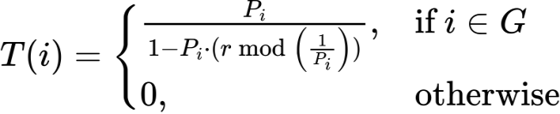
Where i^{th} node probability is Pi which get selected as the CH and T(i) represents the CH election threshold function. The LEACH is having multiple rounds and each round consists of two distinct phases such as the setup phase and the steady state phase. During the setup phase, clusters are formed and CHs are elected. Each node independently determines whether it should become a CH for the current round using a probabilistic threshold function. Nodes that elect themselves as CHs broadcast an advertisement message to neighboring nodes. Non CH nodes then select the CH with the strongest received signal strength and inform the chosen CH of their membership. Once cluster membership is established, the CH creates a TDMA schedule for intra-cluster communication. In the steady-state phase, sensor nodes transmit sensed data to their respective CHs according to the TDMA schedule. The CH collect the received data to eliminate redundancy and relay the collected data to the BS. Since the steady-state phase is significantly longer than the setup phase, the overhead associated with clustering is amortized over multiple data transmission cycles. After that the randomized CH rotation happens which is one of the most important innovations introduced by LEACH is randomized rotation of CHs. The CH role is energy-intensive due to the additional burden of data aggregation and long-range transmission to the BS. To prevent early death of CH nodes, LEACH ensures that the CH responsibility is periodically rotated among all nodes in the network. This rotation mechanism promotes load balancing and ensures that energy consumption is distributed as evenly as possible across the network. Over time, each node has an approximately equal probability of serving as a CH, which enhances network stability and prolongs network lifetime during the initial operational phase.
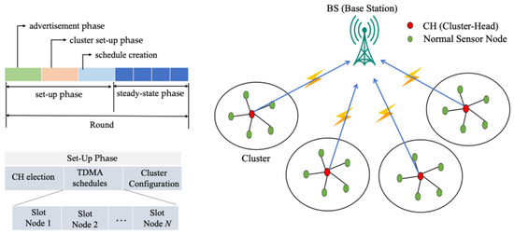
Figure 2.1.1 Representation of the LEACH WSNs for data gathering [5].

Performance Advantages of LEACH, LEACH offers several advantages that contributed to its widespread adoption and influence, energy efficiency by reducing direct transmissions to the BS and enabling data aggregation, LEACH significantly lowers energy consumption compared to flat routing protocols. Distributed operation CH selection does not require global network knowledge, improving scalability. Load balancing by randomized CH rotation distributes energy consumption across nodes and simplicity by making it easy to implement and computationally lightweight. These advantages make LEACH particularly suitable for small scale, homogeneous WSN deployments with static node positions.
Researchers has made numerous contributions but has very significant limitations that limit its real-world applicability to applications needing random or uneven distributions of CHs (certainly, CHs chosen based on a probabilistic algorithm) and also has some issues with clustering that can occur due to the fact that there is no consideration of residual energy available when choosing a CH, thus allowing low energy nodes to become CHs. As all nodes are treated equally regardless of the amount of residual energy left, this is not a suitable assumption for heterogeneous WSNs where nodes will have varying amounts of energy from one to another. Also CHs communicate directly back to BSs through a single hop hence in very large networks with many nodes this is a major limitation. Finally, these limitations are particularly prevalent in the WSNs used in underground mines, which present severe communication impairments due to the extremely adverse environmental conditions experienced there, thus making node replacement because of low energy and/or failure virtually impossible and therefore must optimize the energy use of their networks.

2.1.2 DEEC and Energy Aware Extensions
The DEEC protocol is an extension of the LEACH Protocol and solves one of the major drawbacks of LEACH which is that the CH selection does not take any consideration for residual energy of nodes. In LEACH, when choosing which nodes are to be CHs, every node has the same chance (probability) of becoming CH, with no regard for the residual energy of that node. In DEEC CH selection, each node's residual energy is taken into account via an adaptive probability based upon the node's residual energy relative to the average energy of the network this leads to a more uniform consumption of energy and a longer lifetime for the network and is additionally critical for heterogeneous WSNs. DEEC has been designed for use in a multi-tier heterogeneous networks where the energy of sensor nodes is uneven (with respect to the initial amount of energy provided). This type of heterogeneity is common in real-world application scenarios (due to hardware differences, partially replacing individual nodes, or providing different energy provisioning methods based on their roles as nodes). DEEC uses the concept of energy-aware CH selection to ensure that high-energy nodes take on the highest share of the burden for transmitting data (as they have the highest amount of energy), while lower-energy nodes can conserve their energy and maintain longer lifetimes. The main concept of DEEC is that the probability that a node is selected as a CH should be proportional to the ratio of the node’s residual energy divided by the average energy of the network It is expressed by this:
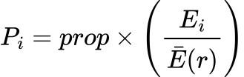
where Pi is the probability of node i becoming a CH in round r, Ei(r) is the residual energy of node i at round r and Eavg(r) is the average residual energy of all nodes in the network at round r. This formulation ensures that nodes with higher residual energy are more likely to be selected as CHs, while nodes with depleted energy reserves are less frequently assigned energy intensive roles.
Similar to LEACH, the DEEC protocol employs a threshold based mechanism to determine and finalize CH selection in each round. In DEEC, this threshold function is designed to incorporate the residual energy of individual nodes relative to the average energy of the network, thereby enabling energy-aware and adaptive CH election in heterogeneous WSN environments. Unlike LEACH, which assigns equal CH selection probability to all nodes, DEEC dynamically adjusts the CH probability so that nodes with higher remaining energy are more likely to become CHs. The threshold function in DEEC is mathematically defined to regulate CH candidacy within a given round and ensures that each node becomes a CH approximately once every epoch, proportional to its energy level. By comparing a randomly generated number with the threshold value, a node autonomously decides whether to assume the CH role. This distributed decision-making process eliminates the need for centralized coordination while promoting balanced energy consumption across the network. The threshold function is expressed as
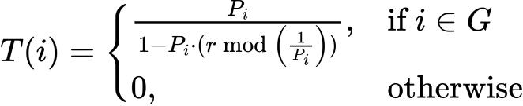
In DEEC, the T(i) represent the condition at which a node will become a CH, probability Pi is the probability that node I will become a CH r is the present round number and G is the set of nodes that have not been CHs for at least 1/Pi rounds. DEEC provides natural heterogeneity without needing explicit role assignments. Because the more advanced nodes will have a higher amount of residual energy for longer periods of time than lower energy nodes, these advanced nodes will be chosen as CHs more often. This dynamic adaptation has led to increased stability time, delayed the time of the first node death and extended the overall lifetime of the network. The DEEC variants that came out after DEEC (DDEEC, EDEEC and TDEEC) have continued to refine the concept of DEEC by increasing the probability conditions to avoid severely punishing nodes with a high amount of energy, as they will have already been selected as CHs more frequently than other nodes. DEEC provides better energy balancing between all nodes, when compared to LEACH, by aligning CH selections to nodes with the highest level of residual energy. These characteristics make DEEC the right choice for any application that requires continuous monitoring, including, but not limited to, environmental monitoring, industrial automation and underground mine safety.

Aside from their benefits, DEEC has some additional limitations, which may hinder their ability to be effective in fast changing or large scale implementations. DEEC is based on pre-defined probability formulas to select CH from nodes, which does not account for quickly changing Topology, Traffic Load and Channel conditions. As a result, the chances of selecting nodes with a high initial energy level too often may lead to an increased likelihood of these nodes running out of energy sooner than expected if their selection or probability scaling is not being controlled. DEEC also focuses solely on the remaining energy of a node when selecting which will become a CH, ignoring other critical metrics related to link quality, packet delivery ratio (PDR), mobility of nodes and sector-wise survivability.

2.1.3 Early Reinforcement Learning Based LEACH Enhancements
There is much interest in using Reinforcement Learning (RL) to enhance both adaptability and intelligence for clustering protocols found in WSNs. While traditional heuristic clustering techniques use static or probabilistic methods for selecting CHs, RL methods allow CHs and sensor nodes to learn the best decision-making policies through a continuous interaction with their environment. Many researchers have utilized RL in conjunction with the LEACH protocol as a response to its static and probabilistic nature to create adaptive clustering methods that are capable of responding dynamically to WSNs. LEACH variants augmented by RL replace or augment the traditional random CH selection process with a decision-making model based on learning. In these studies, the sensor nodes act as agents who can observe WSN states such as residual energy, sensor density, distance to the sink and historical communication success to decide on an action to maximize their long-term rewards. The long-term reward (or value) assigned to an action is based on many factors related to the performance of WSNs, such as energy consumption, throughput, stability period and network lifetime. LEACH-RL and ReLeC (Reinforcement Learning Enhanced Clustering) are two protocols that use RL to determine the roles of CHs dynamically using the Q-Learning algorithm, where CH selection is not only based on probabilistic thresholds but is also based on long-term consequences associated with the CH decision made by the sensor nodes via reward or penalty assignment. The LEACH protocol-enhanced with reinforcement learning (RL) enables each node to maintain a Q Table, which allows nodes to keep track of their history and make more efficient decisions based on previously observed states and actions (such as the decision to elect itself as a cluster head (CH), remaining as a normal member node, changing power level for transmission, or changing cluster affiliation). Over time, through successive rounds of execution, the nodes will adjust their Q Values through feedback received from the environment, allowing the entire network to move towards a more energy efficient CH selection. ReLeC utilizes additional state variables (e.g., other local node densities, distances between nodes) to help decrease the amount of cluster imbalance in the WSN, providing for a better spatial distribution of CHs. The results of simulations performed in the literature show that RL-enhanced LEACH protocols outperform classical LEACH protocols in several important metrics. By limiting the repeated selection of low energy nodes for the position of CH, protocols using RL have been shown to provide for an extended lifetime of the nodes and to provide for greater balancing of energy usage among the nodes. Additionally, the intelligent assignment of the CH role(s) has increased the time until the first node die (FND). The combination of better clustering and adaptive routing decisions has increased the amount of packets delivered to the base station (BS). The decisions made using RL have resulted in a decrease in instability of the clusters and in the need for frequent re-configuration and also provide for an overall improvement in the robustness of the network. Overall, these benefits demonstrate that the use of RL can provide for flexibility to the otherwise rigid traditional clustering protocols and enable the development of self-optimizing wireles sensor networks (WSNs) that can adapt to changing conditions over time.

One of the many issues with RL-based LEACH variations is that they induce considerable computational and communication overhead, making it difficult for IoT nodes to maintain their performance. Updating Q-tables can increase the memory and processing required, which can exceed what is available on low-cost sensor hardware. Additionally, RL-based protocols often require the exchange of state information either within nodes or between nodes and a centralized controller, which leads to higher overhead for control packets and greater energy consumption, partially offsetting the advantages gained through intelligent CH selection. With dense networks, the learning overhead can be considerable, contributing to the rapid depletion of batteries in those nodes. Another major consequence of the limitations with RL-based LEACH is convergence behaviour. Generally, Q-learning will require a reasonable number of interactions before converging to an optimal policy. In a dynamic WSN (wireless sensor network) where nodes may die, relocate or the channel condition may constantly be changing, it is possible that the learning process will never fully converge, thereby producing suboptimal clusters or unstable clusters. Furthermore, many RL-based LEACH implementations assume that centralized training, i.e., access to global knowledge of network state, will facilitate learning. While centralization may simplify the learning process, it creates significant limitations in scalability and creates a single point of failure. Centralized controllers may become communication bottlenecks, particularly in large-scale or geographically dispersed networks, such as underground mining environments. RL based LEACH variants also struggle in highly dynamic scenarios involving node mobility, varying traffic patterns, or rapidly changing environmental conditions. Static state definitions and fixed reward functions may fail to capture complex, real-world dynamics. Additionally, exploration mechanisms in RL can temporarily degrade performance, which is unacceptable in safety-critical applications where consistent reliability is mandatory. These limitations underscore the need for lightweight, distributed and energy-aware learning mechanisms that minimize overhead while retaining adaptability.

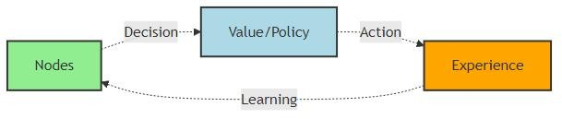
Figure 2.2.3 Generic RL based decision making framework [12]

The diagram above shows how the basic interaction loop between an autonomous agent and its external system (environment) forms the base of the reinforcement-learning-based optimization (RELOC) model for WSNs. The reinforcement-learning agent will observe the current state of the network (e.g., residual energy, density of nodes, quality of links, ratio of successfully delivered packets and load of traffic). The iteration provides the RL agent with a reward that assesses the effectiveness or success of the action taken, in terms of energy consumption, throughput, reliability, or network lifespan. The RL agent then uses this reward feedback to update its policy or value function, thus providing the means for the RL agent to discover an optimal strategy over time.

2.2 Heterogeneity Aware Clustering Protocols
Researchers have come up with a variety of protocols that take the heterogeneity of nodes into account, in order to increase the efficiency of WSN beyond their homogeneous node assumptions. In reality, sensor nodes differ widely in functional capabilities due to differences in battery size, sensor type, processing speed and many other factors as well as the fact that when nodes are replaced, they may not be replaced at the same time or in the same way. Heterogeneity-aware protocols utilize these differences to distribute the load of energy-consuming services evenly across the network. For example, tasks that require a large amount of energy, such as CH selection or long-distance data transmission, can be assigned to nodes that can handle them, based on their characteristics. This helps to maintain network energy balance, improves network stability and increases overall network lifetime. In particular, when selecting CHs, due to their greater available energy and superior communication capabilities, high-energy nodes are selected first, while low-energy nodes are protected from premature failure. This method is especially important for large, mission-critical applications, such as underground mining and industrial monitoring, where consistent energy consumption and continuous coverage are necessary for proper functionality.

2.2.1 SEP Based Heterogeneous Models
The Stable Election Protocol (SEP) is an early clustering protocol developed for use in a heterogeneous wireless sensor network that has nodes in its network that have differing amounts of starting energy. SEP makes use of a weighted election mechanism for choosing cluster heads that allows nodes that are advanced with energy-rich nodes to have a higher probability of being selected as the cluster head and the “normal” nodes have a reduced likelihood of being selected as the cluster head. The weighted election will provide greater opportunities for the nodes that have more energy to elect themselves as the cluster head, facilitating more balanced energy consumption and prolonging the stability period of the network [13]. A two-level heterogeneous SEP model consists of a fraction m of the total number of nodes are advanced nodes that have α times greater amounts of energy than normal nodes. The initial amount of energy for a normal node is denoted by Eo and thus the initial energy for an advanced node is calculated using the following equation
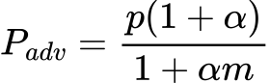
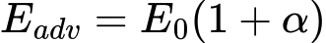
Where the desired percentage of CHs is p, the fraction of advanced nodes is m, α represents the additional energy factor. These equations ensure that the expected number of CHs per round remains constant, while advanced nodes are selected as CHs more frequently than normal nodes. Consequently, SEP significantly improves the stability period, defined as the time until the first node dies. Building upon SEP, the DEEC protocol generalizes heterogeneity support to multi-level heterogeneous networks by dynamically adjusting CH selection probabilities based on residual energy rather than fixed initial energy classes. Unlike SEP, which assigns static probabilities, DEEC continuously adapts to the evolving energy states of the network.
The performance of both SEP and DEEC has been demonstrated to greatly improve the lifetime of the network, the stability interval of the network and the energy efficiency of the operations of the wireless sensor networks (WSN) with heterogeneous deployment. Both protocols enhance reliability by prioritizing energy-rich nodes within a CH role to reduce early node death and ensure that network coverage is more consistent over time. However, despite the performance enhancements, SEP and DEEC do not have intelligent decision-making characteristics as both techniques are fundamentally heuristic based on predefined, mathematical models. This limits their ability to adapt to the complex dynamics of networks, such as node mobility, variation in traffic flow patterns, changing channel conditions and sector-specific survivability needs. In addition, both protocols optimally optimize for energy efficiency and do not consider reliability metrics such as PDR. These limitations present the opportunity for incorporation of learning-based methodologies, such as RL, to facilitate adaptive, multi-objective optimization processes for heterogeneous and dynamic WSNs.

2.2.2 Spatial and Centrality Aware Enhancements
In addition to factoring in energy awareness into clustering protocols, recent enhancements to clustering protocols explicitly factor in spatial characteristics such as node centrality, spatial distribution and inter-node distances when selecting the CH. The rationale behind this approach is based on the premise that an energy-rich node may not be an optimal CH if it is misaligned within the cluster. For example, misaligned nodes will incur greater intra-cluster communication costs and will dissipate energy unevenly. Algorithms such as EEKA treat the selection of the CH as an optimization problem in which the CHs are distributed spatially and centrally to minimize communication energy and meet spatial and energy constraints. A spatially aware clustering approach determines whether or not a given candidate member is suitable to be the CH by looking not only at the remaining energy contained within the candidate but also at the geometric location of the candidate as it relates to the positions of the members within the cluster. There are two very common metrics used to quantify the spatial suitability of a candidate CH: the intra-cluster distance cost Dj and the node centrality metric Cj. The intra-cluster distance cost Dj is the total communication distance between a candidate CH j and all members of the cluster. In other words, Dj is the sum of the Euclidean distances between all of the members of the cluster to candidate Cj.
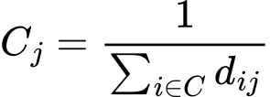
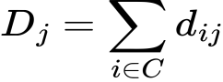
A lower value of Dj indicates that the CH is located closer to the majority of cluster members, which directly translates into reduced transmission energy for intra-cluster communication. Since radio energy consumption increases polynomial with distance, minimizing Dj is essential for achieving energy-efficient clustering and preventing uneven energy depletion among member nodes. As an extension of this concept, the metric for node centrality (Cj) is introduced to represent the position of a node within a cluster with regard to centrality. Centrality is commonly defined as the inverse of the sum of the distances from the candidate CH to every other member of its cluster, such that a higher centrality score indicates that a given node is geometrically closer to the majority of the other nodes within the cluster and thus is a more suitable candidate for the CH position. The centrality of nodes decreases the average communication distance between nodes within the cluster, resulting in lower communication costs and thus greater energy efficiency than clustered systems without central nodes. Additionally, the increased centrality of the nodes leads to a more compact clustering and an overall improvement of the energy balance across the entire cluster. Recent clustering algorithms have addressed the dual objectives of energy efficiency and spatial efficiency by formulating the selection of CHs as a multi-objective optimization problem. This produces a utility function that combines residual energy of nodes and spatial centrality metrics in the selection of the candidate CH. The utility function typically tends to assign higher utility scores to those nodes that possess sufficient residual energy and are located at favorable spatial positions. Introduced weighting factors are used to define the relative importance of the two criteria (energy/spatial) in order to allow for a flexible approach to meet the specific network needs. The utility function is expressed as:
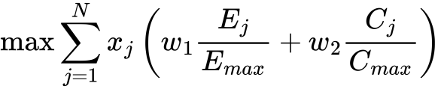
The clustering algorithm chooses CHs to minimize intra-cluster communication cost while ensuring that the energy consumption of all nodes in the network is evenly distributed. Formulating a utility function with communication cost constraints provides extensive improvements to sense data over an extended period the result is a decrease in energy holes and a more even distribution of CHs compared to the current pure energy-based or random selection mechanisms. These utility driven approaches are also beneficial for hybrid clustering frameworks therefore, they will be very useful for WSNs of underground mining.

2.3 Meta-Heuristic Optimization Based Approaches
Meta-heuristic algorithms have been extensively applied to address the NP-hard clustering and routing problems inherent in WSNs, where the objective is to optimize multiple conflicting performance metrics under strict resource constraints. The clustering problem in WSNs determining the optimal number and placement of CHs, cluster membership and routing paths belongs to a class of combination optimization problems that become computationally intractable as network size increases. Similarly, energy efficient routing requires optimal path selection under dynamically changing energy levels, link qualities and traffic conditions, further increasing problem complexity. To overcome these challenges, researchers have employed meta heuristic optimization techniques such as PSO, GA, ACO, SA and DE. These algorithms are inspired by natural phenomena and are capable of exploring large and complex search spaces to find near optimal solutions within acceptable computational time. In the context of WSNs, meta-heuristics are typically used to optimize CH selection, minimize intra and inter cluster communication costs, balance energy consumption and extend overall network lifetime.

Meta-heuristic based clustering algorithms formulate CH selection as a global optimization problem, where candidate solutions represent possible CH configurations. The aim of developing fitness functions is to take into account multiple objectives, including residual energy, distance from node-to-CH (cluster head), network coverage and load balancing of the network. However, meta heuristic approaches tend to have a high computation complexity and convergence times, especially in large-scale and/or dynamic WSNs. In addition, most meta-heuristic algorithms are based on the assumption that the network conditions remain static or require a centralized implementation and offline optimization, making them less adaptable to real-time changes such as node movement, energy depletion, or link variability.

2.3.1 Particle Swarm Optimization (PSO)
PSO provides a way to solve the problem of optimizing the locations of CH in a WSN while taking into account the collective behaviour of a swarm of particles. Each particle in a swarm represents a possible alternative for a clustering solution typically encoded by the location(s) or index(es) of the CHs it has selected. The particles change their locations in the WSN's solution space by learning from the best solution they have previously experienced (personal best) and by learning from the best solution found by the herd (global best). This ability to learn collaboratively from each other makes PSO a suitable algorithm for exploring WSN clustering problems, which represent complex and high dimensional solution spaces. PSO models the co-operative movement patterns seen in flocks of birds and schools of fish [24]. One of the particles in a given swarm corresponds uniquely to one of the particles in the other swarms and may correspond to various clusters across all of the swarms. These particles move within the search space, updating their positions according to their own best performance and the best performance observed among all particles. Over iterations, particles converge toward the best solution.
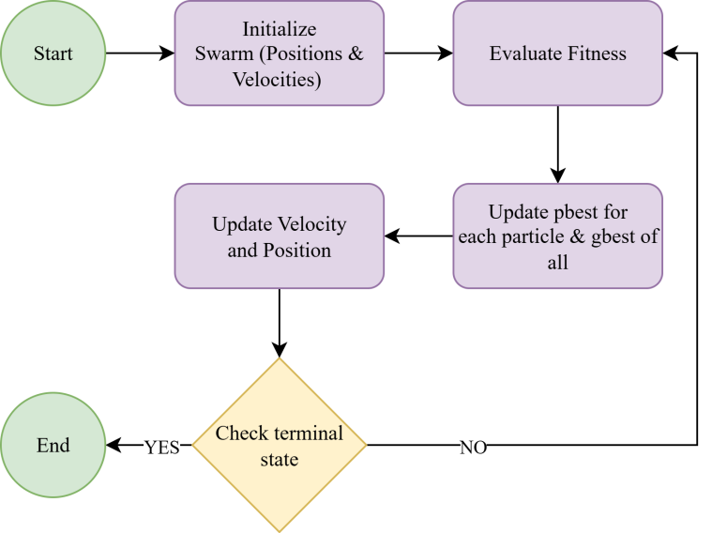
Figure 2.3.1 Flow chart of the PSO algorithm [14]

This figure represents the working principle PSO algorithm. Initially, a group of particles is generated, each symbolizing a candidate solution with randomly assigned positions and velocities. At each iteration, the fitness of all particles is evaluated using the objective function. Each particle then updates its personal best position (pbest) and the global best position (gbest) found by the entire swarm [30]. The velocity and position of each particle are updated according to the below equations:

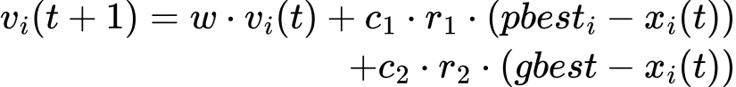
The variables w, c1 and c2 denote inertia weight, Accelerating constant coefficients and r1 and r2 represent random numbers between [0,1]. These equations allow for the inertial (Momentum), cognitive (Self Learning) and social (Swarm Cooperation) factors to be balanced in each particle's current state. This process continues iteratively until the swarm converges on an optimal (or nearly optimal) solution, based upon a defined fitness function. Particles will gradually move together into clusters through repeated velocity/position updates, while the clustering is occurring the particles will also converge on clusters which will minimize distances between particles (Intra-Cluster), minimize overall energy usage (Energy Consumption) and minimize the transmission cost occur by clustering. The iterative updates of each of the functions used for velocity and position provide an abundance of optimization capabilities, however by using global update methods and calculating the fitness function multiple times for each particle increases the computational complexity and communication overhead of the system. This inherent limitation of the existing approaches has led to the need for the development of more adaptive and lightweight alternatives such as hybrid clustering frameworks utilizing RL.

Regardless of these benefits, clustering algorithms based on PSO require multiple iterations of global updates in order to reach an optimal or very optimal solution. An example would be performing fitness evaluation and updating the particle's position for every iteration, resulting in a substantial overhead. Another challenge encountered when implementing PSO is the requirement for centralized control and knowledge of the entire network this limits the use of PSO for large, dynamic, resource-constrained sensor networks. As a result, PSO’s limitations leave it unable to support real-time and safety-critical applications. These failures are a reason for developing hybrids and learning based clustering frameworks with the ability to adapt while reducing overhead.

2.3.2 Genetic Algorithms (GA) and Ant Colony Optimization (ACO)
To model the problem of selecting a CH using a GA, each chromosome is treated like an alternative clustering configuration, while the fitness function typically will be a combination of factors such as residual energy, intra-cluster distance, total communication cost and load balancing among clusters. GA can also help to alleviate energy holes and uneven CH assignments through the same mechanism of continually applying selection pressure to high fitness solutions and injecting diversity through crossover and mutation. However, the requirement to maintain and evaluate such a large number of candidate solutions over multiple generations translates into significant computational load, therefore, GA CH selection is not feasible for real-time implementations on sensor nodes as their resource constrained environment leads to extreme amounts of memory usage and control messaging overhead. ACO formulates routing and clustering as a probabilistic path evaluation algorithm when an ant moves through the WSN, that ant deposits pheromones based on how much energy it consumed to get to that node and on how far away it is from that node the pheromone level of a given node can also be influenced by the amount of residual energy of that node. As time goes by, nodes that are used more often will develop a higher pheromone level and therefore produce a more optimal routing structure for ants to follow.

However, in highly dynamic environments such as mobile WSNs or underground mining scenarios with frequent link quality variations the pheromone information can quickly become outdated. This necessitates frequent re-initialization or accelerated evaporation, further increasing overhead and destabilizing convergence behavior. Another critical limitation of both GA and ACO methods lies in their sensitivity to parameter tuning. Performance strongly depends on carefully selected parameters, including population size, crossover and mutation rates in GAs and pheromone evaporation rates, exploration exploitation balance and ant population size in ACO. Determining optimal parameters often requires extensive offline experimentation, reducing the adaptability of these techniques.
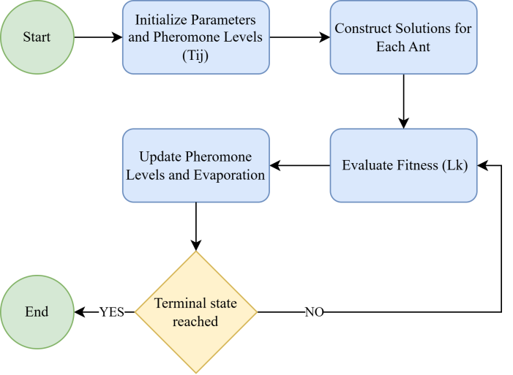
Figure 2.3.2 Flow chart of the ACO algorithm
This figure show the working principle of ACO algorithm. It simulates artificial ants that iteratively construct solutions using pheromone trails and heuristic information. The process begins with the initialization of parameters and pheromone levels on all paths. During solution construction, each ant builds a solution based on the probability of selecting the next path. After all ants complete their paths, the pheromone update phase reinforces paths used by better solutions while allowing pheromone evaporation to prevent premature convergence and find optimal path. The algorithm proceeds in an iterative manner until a stopping criterion such as reaching the maximum number of iterations or achieving convergence is met [31]. The core equations of ACO are the path selection probability probability are expressed as :
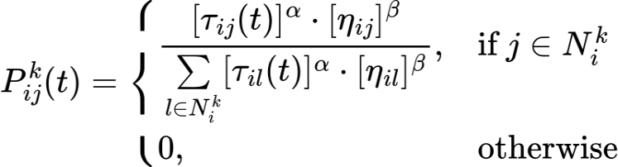
where Pij is probability that ant k moves from node i to node j, Tij is pheromone concentration on edge (i,j) at time t. ηij is equals to 1/dij that is heuristic information (inverse of distance or cost). α, β are control parameters for pheromone and heuristic influence.
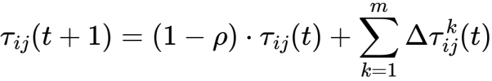
This equation represents pheromone update rule, where ρ represents pheromone evaporation rate (0<ρ<1), m is total number of ants and ΔTij amount of pheromone deposited by ant k on edge (i,j)
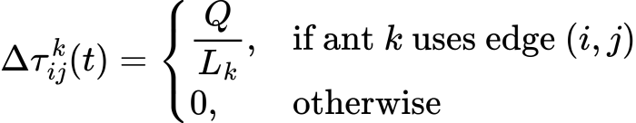
This represents pheromone deposition amount, where Q is pheromone constant and Lk is total cost or path length of the tour constructed by ant k. Furthermore, GA and ACO based approaches generally lack inherent mechanisms for continuous online learning. Once an optimal or near-optimal solution is obtained, adapting to node failures, energy depletion, or environmental changes typically requires rerunning the optimization process from scratch or with limited reuse of prior solutions. This restart-based adaptation is inefficient for long-lived networks and conflicts with the real-time decision-making requirements of safety-critical applications. Although evolutionary and swarm intelligence techniques such as GA and ACO offer strong global optimization capabilities for CH selection and routing, their computational intensity, slow convergence in dynamic conditions, reliance on centralized or offline processing and limited online adaptability significantly constrain their practical applicability.

2.4 Fuzzy Logic and Multi Criteria Clustering
Fuzzy logic-based clustering methods deal with the natural uncertainty and imprecision associated with wireless sensor networks (WSNs), as well as the nonlinear characteristics exhibited by WSNs, allowing for multiple criteria decision-making in determining the cluster head (CH). Fuzzy inference systems (FIS) do so by using fuzzy logic variables and membership functions instead of traditional threshold-based and probabilistic models to express parameters such as residual energy, node density, the distance to a cluster centroid (or base station), link quality and traffic loads. In doing so, the FIS combines these variables according to a set of fuzzy rules, allowing the protocols such as MRCH and several derivatives of fuzzy LEACH to make more balanced and context-oriented decisions when choosing cluster heads. This, in turn, reduces frequent CH re-elections and the uneven depletion of energy. Finally, fuzzy logic has enabled these protocols to dynamically adapt to changing heterogeneous networks and gradual changes in node energy or topology. Fuzzy based clustering schemes have shown significant improvements in key performance metrics such as PDR, network stability period, throughput and overall lifetime. In addition, the ability of fuzzy based clustering schemes to trade-off conflicting goals such as reducing communication distance while maintaining a high level of residual energy makes them more useful for environments that are highly variable and for which deterministic models do not work well.

Although fuzzy logic based clustering methods provide many benefits, they also have significant limitations in practice. Specifically, to develop an effective fuzzy inference system, need a rule base and design appropriate membership functions. Additionally, as the number of parameters that are input into a fuzzy logic system increases, the number of rules in the rule base can increase exponentially. This means that there is a much greater demand for computing resources and memory. The consequence of the rule explosion problem is that it can become even more serious in large- scale or heterogeneous WSNs,.

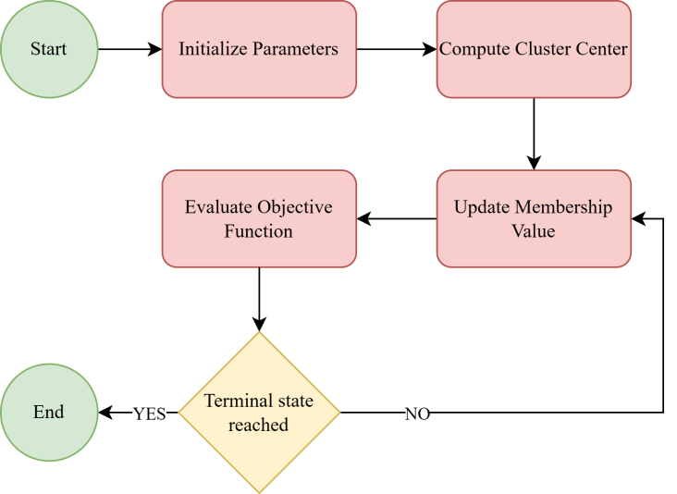
Figure 2.4 Flow chart of the FCM algorithm

This figure illustrates the working principle of the FCM algorithm. Here the process begin with the initialization of the membership matrix U. It assigns random membership values to each data point for all clusters. Next, cluster centers are computed based on the current membership values. Then the algorithm updates the membership degrees for each data point using the updated cluster centers. Later on the objective function is evaluated to measure clustering performance. If the change in membership values or cluster centers between iterations is smaller than a predefined threshold, the process is said to have converged, otherwise, the algorithm repeats the update steps. Once convergence is achieved, the final cluster assignments are generated, representing the optimal fuzzy partition of the dataset
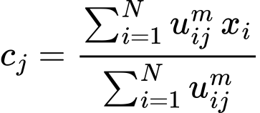
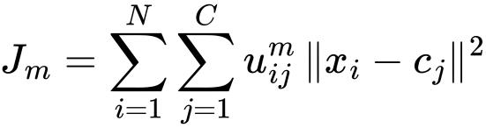
These equation represents the objective function that FCM seeks to minimize. It measures the total weighted distance between all data points xi and the cluster centers cj. The weight is given by the membership value Uij, m which indicates how strongly a data point belongs to a particular cluster. It is used to update the cluster center. Each cluster center is calculated as the weighted mean of all data points, where the weights are the membership degrees raised to the power m.
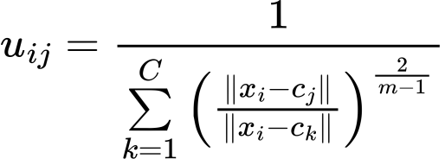
This equation defines how the membership value Uij of each data point to each cluster is updated. From equation we can conclude that the membership is inversely related to the distance between the data point and the cluster center. The ratio term ensures that all membership values for a data point sum to 1 across all clusters for maintaining normalization

Moreover, executing fuzzy inference comprising fuzzification, rule evaluation, aggregation and defuzzification introduces non-negligible processing overhead and energy consumption. For ultra-low-power sensor nodes with limited processing capability, memory and battery capacity, this overhead can offset the energy savings gained from improved clustering decisions. Consequently, many fuzzy based approaches rely on centralized or cluster level processing, which increases communication overhead and reduces fault tolerance. In addition, most fuzzy logic based clustering protocols lack autonomous learning or self optimization capabilities. Once the rule base and membership functions are defined, they remain static throughout network operation, limiting adaptability to long term environmental changes, evolving traffic patterns, or progressive energy heterogeneity. Updating or re-configuring the fuzzy system typically requires manual intervention or offline retraining, which is impractical for long lived or safety critical deployments.

2.5 Reinforcement Learning Based Approaches in WSNs
RL has gained significant attention as a promising solution for adaptive and intelligent WSN management. It is based on the concept of interaction between an intelligent agent and its surrounding environment. In WSN applications, sensor nodes, CHs or centralized controllers can be modeled as learning agents that observe the current network state, perform actions such as CH selection, routing decisions or transmission power adjustment and receive feedback in the form of rewards or penalties. Through continuous interaction with the network environment, the agent learns an optimal policy that maximizes long term performance objectives such as network lifetime, energy efficiency, throughput and communication reliability [17].

Several RL algorithms have been applied in WSN research. Among them, Q-Learning is one of the most widely adopted model free RL techniques. In Q-Learning based clustering protocols, each node maintains a Q-table that stores the expected reward for selecting specific actions under different network states. Over multiple communication rounds, nodes update their Q-values based on observed rewards, gradually learning energy efficient CH selection and routing strategies. Q-Learning based protocols have demonstrated improvements in network lifetime, stability period and throughput compared to classical clustering methods.

2.5.1 Q-Learning and Policy-Based Methods
Research has also been conducted to investigate policy-based reinforcement learning (RL) and deep reinforcement learning (DRL) approaches to improve the performance of wireless sensor networks. The neural networks or policy gradient methods provide these methods with an ability to approximate an optimal strategy or policy to operate in large scale networks with complex state spaces. DQNs and actor-critic networks have been shown to be effective in implementing adaptive routing, managing energy and controlling topologies. Q-Learning, SARSA and DQN algorithms are used in selecting cluster heads (CH), routing and managing topologies in wireless sensor networks [17]. The EER-RL protocol dynamically adjusts CH roles by continually learning and observing energy consumption, thereby improving adaptation to changing conditions and resulting in greatly improved performance. However, most of these approaches require significantly higher levels of computational and memory resources than available on typical low power sensor nodes. The following equation provides a representation of Q-Learning.
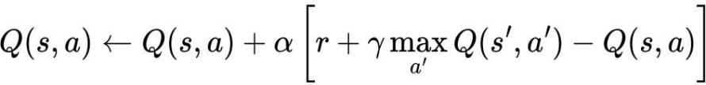
Where Q(s,a) denotes the action value function, which predicts the expected total reward an agent can achieve by taking action a in state s and then following the optimal policy afterward. The learning rate α, which ranges between 0 and 1, controls how much the newly gained information influences the existing value estimates, balancing the trade off between learning speed and stability. The immediate reward received after performing action ‘a’ is represented by r, while the discount factor γ(gamma), also between 0 and 1, determines the relative importance of future rewards as compared to immediate ones [18]. The term Q(s′,a′) represents the maximum estimated value of the next state s′ over all possible actions a′, which helps the agent make decisions that maximize long term returns. The difference between the target value [r+γmaxQ(s′,a′)] and the current estimate Q(s,a) is referred to as the Temporal Difference (TD) error [18] which quantifies the discrepancy between predicted and actual outcomes. By iteratively applying this update after every round of operation, each node refines its action-value estimates, allowing it to improve CH selection decisions over time.

2.5.2 Limitations of Centralized RL
With centralized RL systems, there is a singular controller that usually resides at a base station or central processing site that collects the global state of the network and performs policy learning to determine the CH with which to connect, to select the best route and manage resources. The central controller will simplify the algorithm implementation by having access to the entire state of the network and to the policy applied throughout the network. However, this leads to major limitations in its practical application within real-world WSN deployments, especially within hostile or changing environments such as underground mining [18][19]. The scalability of centralized RL systems is a significant limitation. The amount of state information required to operate the centralized RL system is directly proportional to the size of the WSN. As the size of a WSN increases, the amount of state information that must be collected and processed increases significantly. Large-scale WSNs can contain hundreds, if not thousands, of sensor nodes, each of which provides residual energy, link performance, traffic load and spatial location data [20]. At a central site, collecting and processing all of this data by a single controller results in significant computational complexity and increases decision latency. As a result, centralized RL systems become inefficient and become nearly impossible to scale as the density of the sensor nodes or geographical distribution increases.

Communication overhead presents another major problem in the model of centralized Reinforcement Learning (RL). In order for centralized RL to function, there must be periodic transmissions of state information from sensor nodes to the central controller as well as periodic transmissions of control decisions, by the central controller, to the sensor nodes in the network. Therefore, bidirectional communication results in large amounts of control packet overhead, which in turn depletes additional energy and leads to a decrease in the overall life of the network. When a Wireless Sensor Network (WSN) has limited energy resources, high communication overhead can offset the energy savings that were achieved through intelligent clustering and routing optimization [19][20]. In addition to communication overhead, centralized RL frameworks can experience failures due to a single point of failure. Because the learning phase and decision-making phase both depend on the central controller, if the base station fails or the communication link is disrupted, the entire performance level of the network will suffer [21]. The limitation of a single point of failure is particularly critical in safety critical applications like monitoring underground mining activities. Without the ability to continuously monitor the status of the network for hazard detection or worker safety, the safety of workers could be jeopardized.

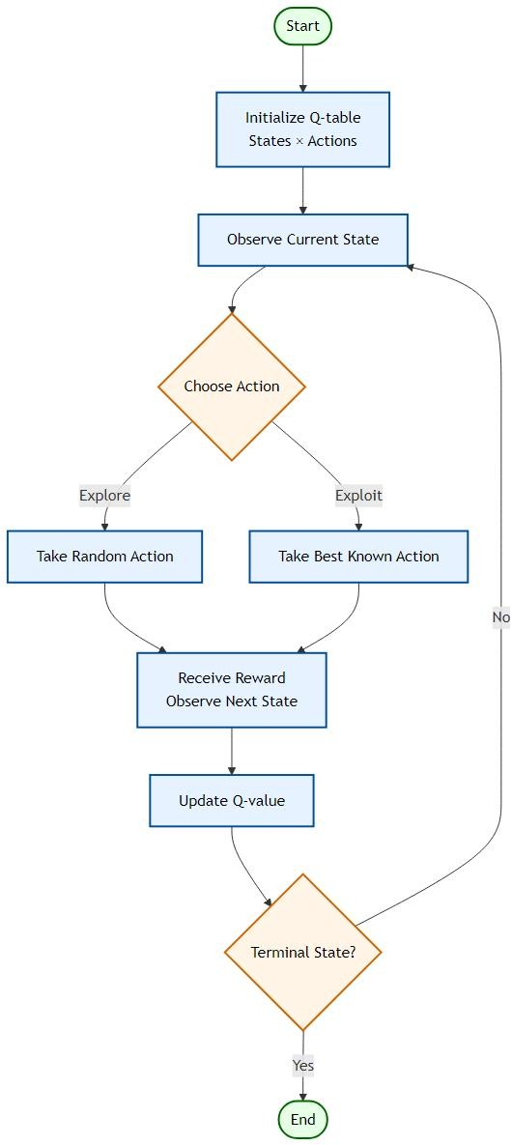
Figure 2.5 Flow chart of the Q-Learning algorithm

2.6 Hybrid Clustering and Intelligent Frameworks
Hybrid methods set out to combine the best aspects of traditional clustering protocols and meta heuristics with fuzzy logic and RL to boost the effectiveness of WSN. By incorporating energy efficient CH selection along with spatial clustering methods and RL-based adaptive decision-making processes into a blended multi-layered hybrid framework, these approaches allow for the simultaneous optimization of multiple WSN performance metrics. Energy Optimized Cluster and Grid Structure (EOCGS) is one such approach that determines how many clusters and grid heads should be used in order to achieve optimal energy efficiency within the network [19]. It has recently been found via research studies that hybrid intelligent hybrid frameworks outperform conventional independent clustering approaches in the areas of increased adaptability, increased energy efficiency in dynamic networks.

2.7 Critical Analysis and Research Gaps
Although there has been much advancement made toward energy-efficient techniques for clustering and routing in WSN, the current methods present some key issues related to how these systems operate. Meta-heuristic optimization algorithms are very effective at performing global search well but can take an extremely long time and require a significant amount of computational power, making them impractical in real-time applications when you consider the limitations imposed by the constraints of the sensor networks. Classical clustering protocols are limited due to the use of either probabilistic or static methods for selecting CHs, which cause the nodes to consume energy unevenly and deplete very quickly, that is, too soon. RL based systems allow an adaptive form of decision making but, unfortunately, most RL based systems use a centralized learning which can cause problems of scale, high communication overhead and risk of single point failure.

Existing challenges and RLHC Approach

- Early node depletion in classical clustering protocols: RLHC applies energy-aware CH selection to ensure balanced energy consumption.

- Scalability and communication overhead in centralized RL models: RLHC adopts a distributed adaptive learning mechanism to improve scalability and robustness.

- Static decision-making in existing Q-learning approaches: RLHC introduces dynamic state monitoring including residual energy, cluster load and communication reliability for adaptive optimization.

- Lack of spatial awareness in traditional clustering techniques: RLHC integrates EEKA and K-Means clustering to ensure reduced communication distance.

- Poor adaptability to underground mining environments: RLHC provides continuous learning based adaptation to handle dynamic and harsh underground network conditions.

2.8 Summary of Energy-Efficient WSN Studies
Table 2.1 summarizes key energy efficient clustering and routing studies, highlighting their techniques and identified research gaps.
SL  No | Paper & Year | Optimization Technique Used | N/w Lifetime Improved | Limitations / Research gap
1 | Zhang et al. (2021) Energy-Efficient Clustering Routing Protocol Based on Weight for WSN in Coal Mine[5] | Weighted Clustering  (Residual energy and Distance factors) | Improved by balancing energy in CHs | Does not adapt for dynamic topological
2 | Li et al. (2021) WSN Coverage Optimization in Coal Mine Based on Improved Whale Optimization Algorithm[6] | Whale Optimization Algorithm (WOA) | Extended by minimizing redundant coverage | High computational complexity for low-power sensor nodes
3 | Wang & Liu (2021) A Hybrid Energy-Efficient Routing Protocol for Underground Coal Mine Monitoring[7] | Hybrid Routing  (Combining Tree-based and Cluster-based) | Prolonged network life in large scale linear topologies | Complexity in switching between modes leads to latency
4 | Chen et al. (2022) Research on Energy Balanced Routing Strategy for Coal Mine WSN based on Mobile Sink[8] | Mobile Sink (Sink moves to collect data) | Improves lifetime by 20% vs LEACH. | Requires precise path planning for the mobile vehicle.
5 | Kumar & Pal (2022) Fuzzy Logic Based Clustering Algorithm for WSN in Underground Mines[9] | Fuzzy Logic Controlle | Better decision making for CH selection | Rule-base design is complex and static.
6 | Al-Kaseem et al. (2022) Optimized Energy-Efficient Path Planning with Multiple Mobile Sinks[10] | Ant Colony Optimization + Genetic Algorithm | 66% vs. standard LEACH | Heavy computation demand  Static environment
7 | Raed et al. (2022) Efficient Energy Mechanism for Underground Mining Monitoring[11] | Enhanced LEACH + DEECP | 25% vs standard LEACH | No mobility support  Static environment
8 | Salman et al. (2022) Optimization of LEACH Protocol for WSNs in Terms of Energy Efficiency and Network Lifetime | Particle Swarm Optimization | 30% vs. standard LEACH | No mobility support  Non heterogeneous environmnt

SL  No | Paper & Year | Optimization Technique Used | N/w Lifetime Improved | Limitations / Research gap
9 | Gamal et al. (2022) Enhancing Lifetime of WSNs Using Fuzzy Logic LEACH and Particle Swarm Optimization[13] | Fuzzy + Particle Swarm Optimization | 18% vs. standard LEACH | Increased control overhead from fuzzy inference
10 | Mohapatra et al. (2022) Mobility Induced Multi-Hop LEACH Protocol in Heterogeneous Mobile Network[14] | Modified multi-hop LEACH | 20% vs. standard LEACH | Assumes uniform mobility  Non heterogeneous environmnt
11 | Liu et al. (2023) Improved Grey Wolf Optimizer (GWO) for 3D Node Coverage in Mines[16] | Grey Wolf Optimizer (GWO) | Maximizes coverage in 3D laneways | Does not fully account for signal multipath fading in tunnels
12 | Adnan et al. (2023) LoRa-based Wireless Underground Sensor Networks: Evaluation and Deployment[17] | LoRa (Long Range) Modulation (Physical layer optimization) | Extend battery life due to low power usage. | Low data rate  High Packet collision probability.
13 | Wu et al. (2023) Fault Tolerant Routing Mechanism for Underground Coal Mine WSN[18] | Multipath Routing  (Redundant paths) | Increases reliability | Higher energy cost due to redundant data transmission
14 | Yang et al. (2023) Dynamic Duty Cycling Scheme for Underground Mine Disaster Monitoring[19] | Dynamic Duty Cycling (Sleep/Wake scheduling) | Drastically reduces idle listening energy usage. | Increased delay in event detection and synchronization issues in deep tunnels
15 | Bibi et al. (2023) Energy Harvesting WSN Routing Protocol for Underground Applications[20] | Energy Harvesting Aware Routing | Extend lifetime if harvesting matches usage | Harvesting sources are intermittent requires battery
16 | Tadele A. Abose et al. (2023) Optimized Cluster Routing Protocol With Energy-Sustainable Mechanisms for Wireless Sensor Networks[21] | Stable Election Protocol | 36% vs  standard  LEACH | No Multi-hopping  Homogenous network
17 | Aleem & Thumma (2025) Hybrid DEEC EEKA RL in IoT- WSNs[23] | Residual energy  ratio (DEEC) EEKA constraints + RL | 17.5% vs  standard  LEACH | Computational overhead, No mobility support

Chapter 3

Problem Statement
Wireless Sensor Networks (WSNs) have emerged as a critical technology for enabling real-time monitoring and automated operations in hazardous, hard-to-access locations like underground mines, industrial facilities and disaster recovery settings. In the context of underground mining, WSN sensor nodes are deployed to monitor key parameters such as gas concentration, temperature, humidity and structural stability. To enable early detection of hazards and to ensure the safety of workers, there must be dependable and continual communication between the sensor nodes. However, the inherent characteristics of underground mining pose numerous technical challenges for the successful implementation of WSNs, including energy efficiency, reliability of communication scalability of the network and adaptability to constantly changing conditions of the environment.

Also, other challenges presented by the deployment of WSNs in an underground mining environment include irregular tunnel geometry, extreme signal degradation, variable channel conditions and the development of dynamic node movement due to mining operations. These challenges cause unpredictable patterns of energy depletion, instability in communication and variability in the formation of clusters. Current clustering and optimization approaches are not intended for use under conditions that require complex deployments and are critical to safety.

Sensor nodes in WSNs generally have insufficient battery life, making it difficult and costly to replace or recharge batteries in underground mine applications. Therefore, the most important design constraint for ensuring the continuing operation of an underground WSN is efficient energy use. To improve energy efficiency, the two well-known clustering protocols (LEACH and DEEC) cluster nodes together in groups and assign each group a CH from among the nodes in the group. As a result, this approach reduces the communication overhead but has a tendency to result in an unequal amount of energy being used and/or nodes failing early due to the probabilistic or static way that CHs are elected.

Thus, there is a need for an energy-efficient, multi-objective and adaptive clustering framework that dynamically optimizes the cluster(s), communication reliability of the network and the life of the network while keeping the computational effort low enough to meet the constraints of resource-constrained sensor nodes.

The proposed RLHC framework for will tackle the items presented above by developing an architecture using multiple levels of clusters that can dynamically select CHs, optimize the distribution of clusters and adapt WSN communication based on the instantaneous environmental changes. The goals of the framework are to improve energy efficiency and conserve the unusable time, extend the useful life of the network, improve packet delivery reliability and develop a robust and scalable WSN to support operations throughout an entire of an ultra-heavy underground mines environment.
Chapter 4

Proposed Solution

The proposed Reinforcement Learning with Hybrid Clustering (RLHC) framework introduces a hierarchical multi-layer architecture designed to address energy imbalance, inefficient cluster formation and unreliable communication in underground wireless sensor network deployments.

As illustrated in Fig. 4.1 End-to-End Layer Integration, RLHC integrates deterministic optimization methods with adaptive learning mechanisms. Each layer progressively refines network organization, beginning from energy-aware candidate selection to intelligent communication management.

The RLHC framework consists of five sequential layers:

- Distributed Energy Efficient Clustering Protocol (DEEC)
- Energy Efficient Knapsack Algorithm (EEKA)
- K-Means Spatial Clustering
- Reinforcement Learning using Q-learning
- Communication Management Layer

Each layer performs a specific optimization task while passing refined information to the subsequent stage.
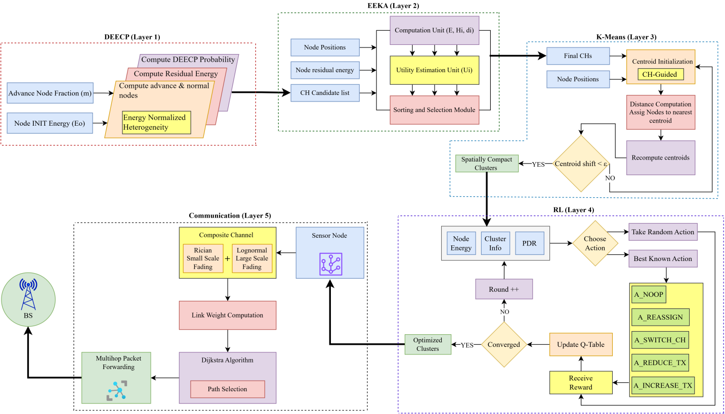
Figure 4.1 End-to-End Layer Integration

4.1 Distributed Energy Efficient Clustering Protocol (DEEC)
The first layer of RLHC generates an energy-aware pool of candidate CHs using the Distributed Energy Efficient Clustering Protocol (DEEC).
Wireless sensor networks deployed in underground mining environments exhibit heterogeneous energy distributions due to varying node roles and sensing workloads. Traditional probabilistic clustering schemes fail to account for residual energy variations, resulting in premature node failures.
DEEC addresses this limitation by assigning CH selection probability proportional to the residual energy of each node [22].

The probability of node i becoming a CH is defined as Pi:
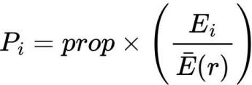
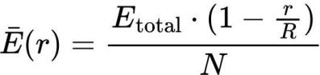

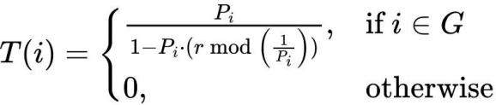

Where Popt denotes optimal CH probability. Ei(r) represents residual energy.
Eavg(r) denotes network average energy at round r.

Nodes possessing higher residual energy obtain increased probability of selection. The output of this layer is an energy-qualified candidate CH set.

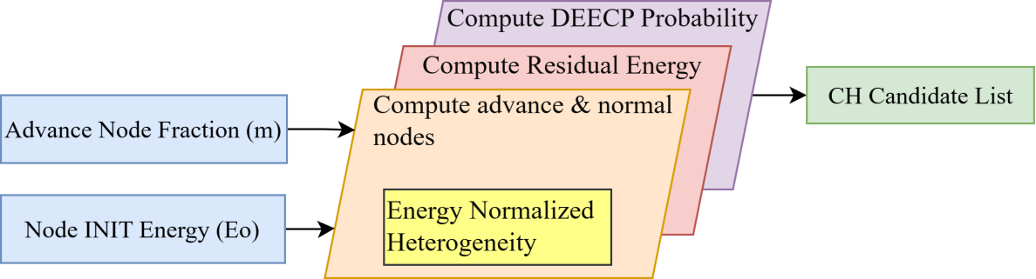
Figure 4.1.1 DEEC Protocol

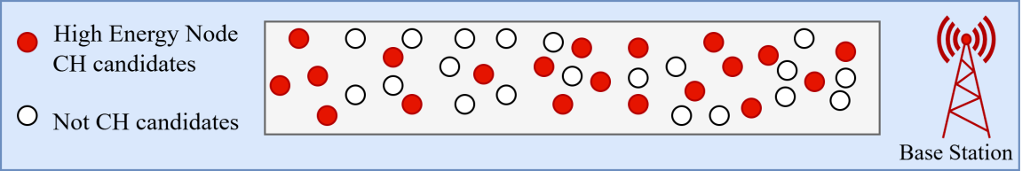
Figure 4.1.2 Candidates CHs

4.2 Energy Efficient Knapsack Algorithm (EEKA)
Although DEEC produces energy-efficient candidates, CHs may become spatially concentrated, leading to uneven coverage and communication congestion.
To address this issue, RLHC employs EEKA, which selects an optimal subset of candidate CH that maximize network utility while satisfying spatial distribution constraints [23].

The optimization objective is expressed as:
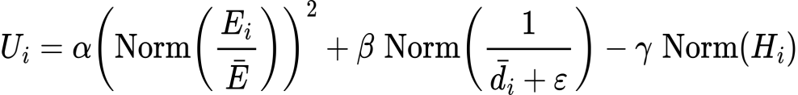
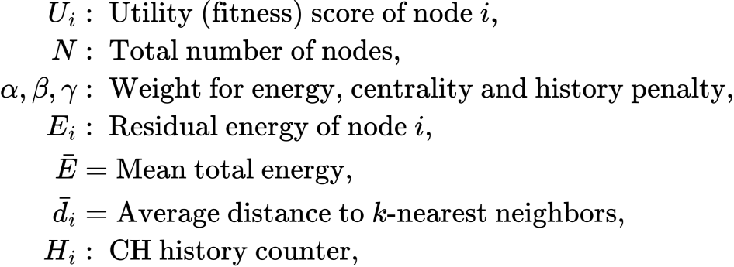
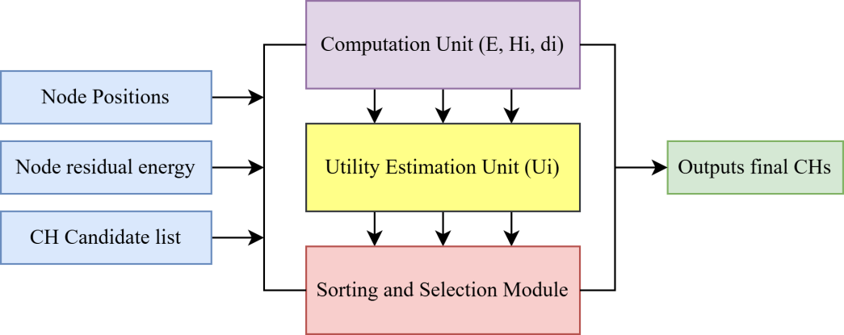
Figure 4.2.1 EEK Algorithm

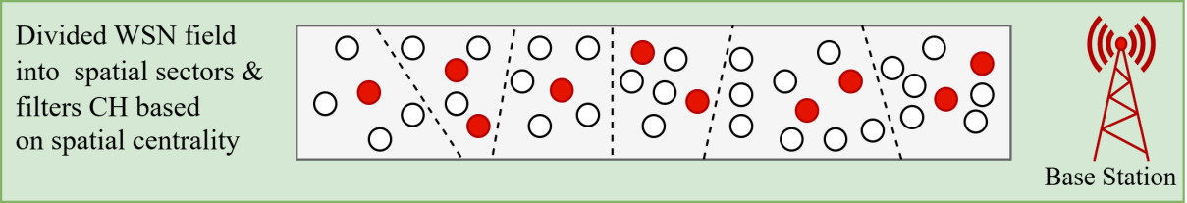
Figure 4.2.2 Spatially distributed CHs

4.3 K-Means Spatial Clustering
Following CH optimization, RLHC performs spatial clustering using the K-Means algorithm. The objective is to create geographically compact clusters, minimizing intra cluster communication distance and transmission energy consumption [24].
It is an iterative algorithm expressed as:
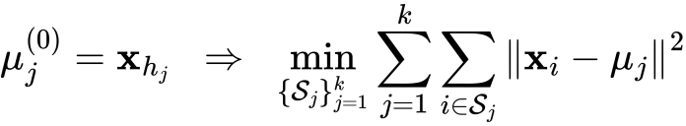
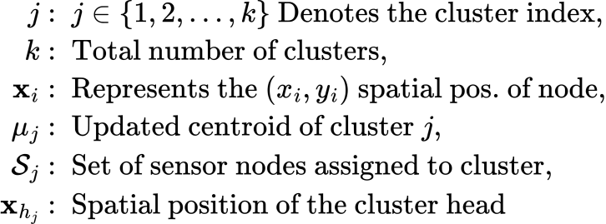
The compact clusters reduce transmission distances and simplify learning complexity by allowing reinforcement learning decisions at cluster level instead of node level.
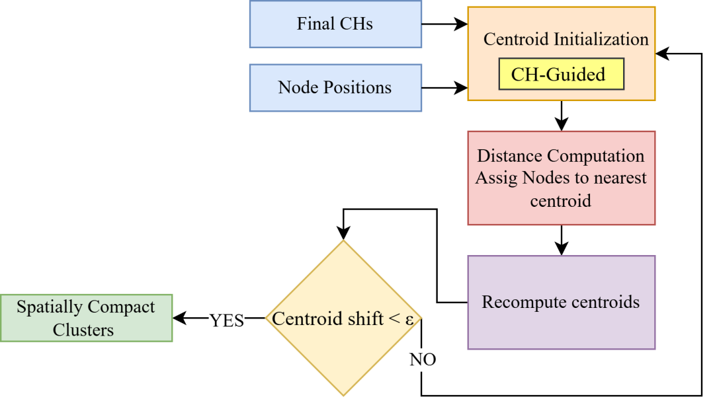
Figure 4.3.1 K-Means Algorithm

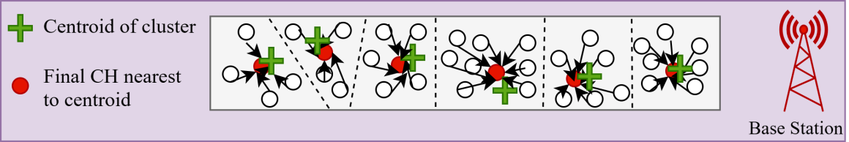
Figure 4.3.2 Spatially compact cluster

4.4 Reinforcement Learning Using Q-Learning
The fourth layer introduces intelligence into RLHC through Q-learning based adaptive optimization. Static clustering approaches cannot adapt to dynamic underground conditions such as link fading, node mobility, or traffic variations [25]. The RL agent observes network state at each communication round. Adaptive decision making by observing network metrics (energy, cluster load, PDR) and chooses adaptive actions.It learn from feedback by evaluating the outcome of each action using a reward function and updates the Q-table.

where α is the learning rate that determines how much new information overrides old knowledge, γ is the discount factor that defines the importance of future rewards and ‘a’ represents the action taken by the agent. This update allows the agent to iteratively improve its policy by balancing immediate rewards with long-term benefits, enabling more optimal decision making over time.
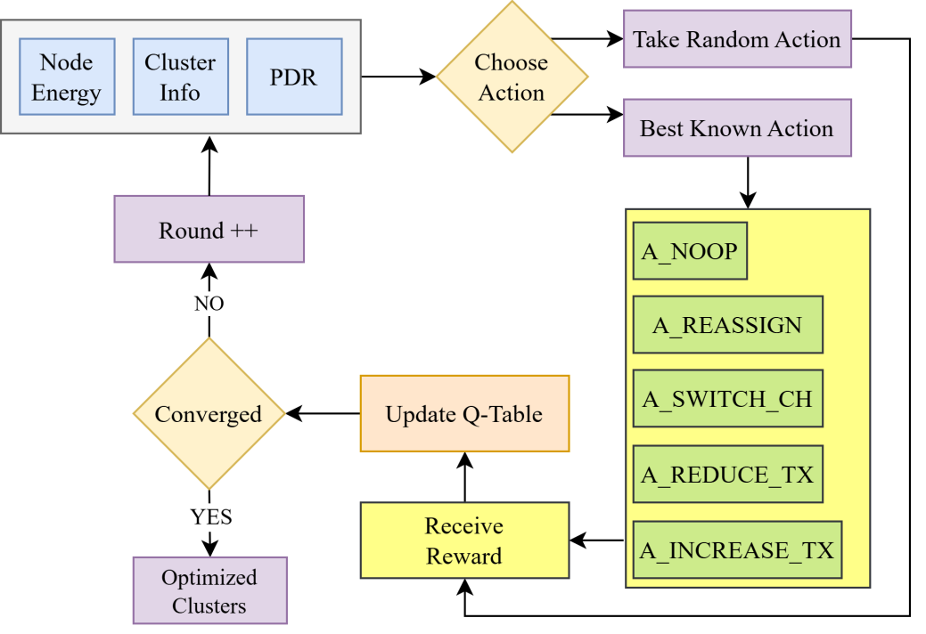
Figure 4.4.1 Reinforcement Learning Algorithm
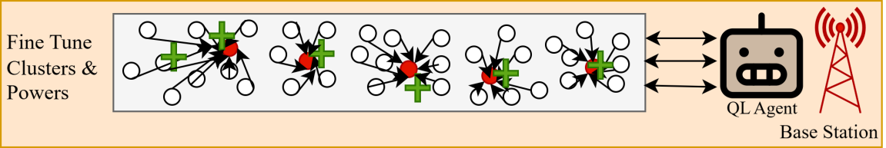
Figure 4.4.2 Centralized Q-Learning Agent Optimizing Cluster Formation

4.5 Communication Management Layer
The final RLHC layer ensures reliable data communication between sensor nodes and base station. Multi Hop routing, Data forwarding paths are determined using Dijkstra’s shortest path algorithm [26]. The cost metric incorporates both distance and link reliability. Also composite channel model underground mining environments experience severe multi-path fading and shadowing. RLHC models channel behavior using Rician fading for tunnel wave guide propagation and Log-normal shadowing for obstruction losses. Received power is modeled as:

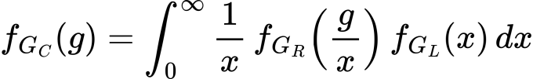

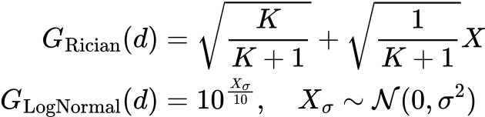

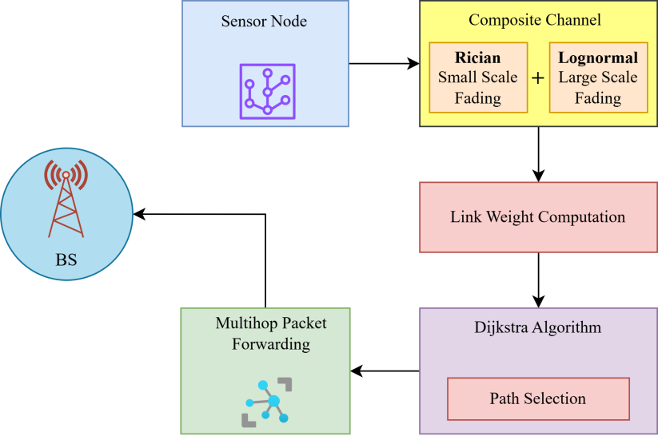
Figure 4.5.1 Communication Layer

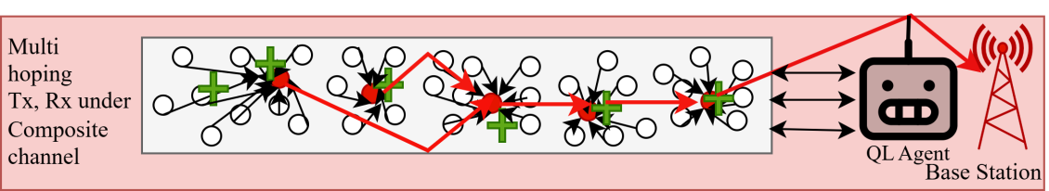
Figure 4.5.2 Multihopping communication under composite channel
The proposed solution follows an end-to-end integrated pipeline modeling approach to ensure seamless coordination between sensing, decision making, learning and communication processes. The objective of this pipeline is to jointly optimize energy efficiency, network lifetime and CH selection through reinforcement learning–based adaptation. The pipeline begins with network initialization, where sensor nodes are randomly deployed within the monitoring region and categorized according to heterogeneous energy levels such as normal, high-energy and super nodes. Each node is assigned an initial energy budget, spatial coordinates and communication parameters required for transmission and reception operations. In the state construction layer, relevant network parameters are extracted to represent the environment state for learning. These parameters typically include residual node energy, distance to the base station, neighborhood density and historical participation in CH selection. The state vector provides a compact representation of node health and network topology at a given round.

The next phase correspond to Q-learning agents, where every eligible agent will use their Q-table to evaluate their potential actions as a CH or to continue to be a member node. They will use an exploration-exploitation strategy (i.e., ε-greedy), to pick their actions, which will give them the highest level of learning and stability. After selecting their action, they will go to the next phase by allowing the cluster-formation component of the algorithm to group the nodes into close clusters where it is possible to communicate with low communication costs. In the following step, eligible CHs will send out advertisement messages by CHs, which member nodes will receive and associate with them based on energy efficiency. At this point, there will be a reduction in communications by reducing the number of redundant messages generated in the cluster and producing consolidated aggregated data.

After the cluster has been formed, the data aggregation and transmission phase will occur. Intra-cluster sensing will be completed by aggregating all received data by CHs and eliminating all redundancy from the received packets prior to compressing the collected data and then transmitting the compressed data to the base station. The energy consumed while sending the data will be calculated based on the adopted radio energy model when the data was sent and received.

Subsequently, the reward evaluation method computes reinforcement signals based on performance indicators such as residual energy balance, successful packet delivery, cluster stability and network lifetime improvement. The computed reward updates the Q-values using the learning rule, enabling adaptive optimization across successive rounds.
The pipeline ends with the network update and iteration phase, where node energies are reduced according to communication costs. Then the dead nodes are identified and the environment transitions to the next state. This iterative learning process continues until network termination conditions are reached, such as 90% node death or complete node depletion or predefined simulation rounds.

4.6 RLHC Deployment - Centralized Reinforcement Learning Model
A single agent located at the base station or sink node maintains a single global Q-table in a centralized reinforcement learning environment. The centralized agent will gather statistics from all clusters throughout the network in order to make decisions using complete system knowledge. Benefits of centralization can provide an organization with global visibility of both network topology as well as how much energy is distributed throughout it. It also allows for faster convergence due to consistent learning updates. It simplifies coordination between different clusters.

However, there is additional communication overhead associated with centralized RL since nodes will need to send state information to the sink node on a frequent basis. The sink is also a computational bottleneck and can serve as a single point of failure. Through the new pipeline, centralized Q-learning can create optimized clusters by evaluating global reward trends and sending out updated policies for CH rotations and routing strategies to achieve very strong short-term throughput performance.

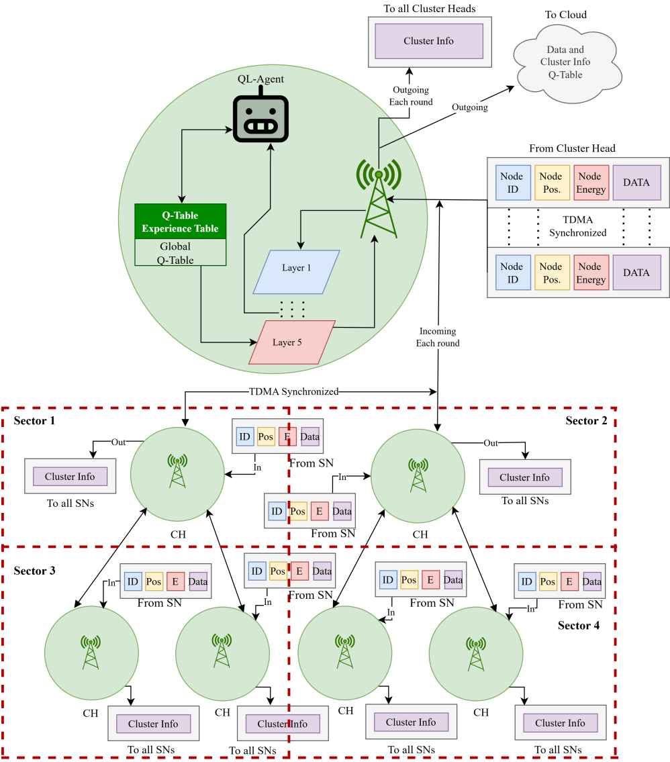
Figure 4.6.1 Centralized RLHC Deployment

4.7 RLHC Deployment - Federated Reinforcement Learning Model
The Federated RL mechanism is being employed to resolve the restrictions that exist as a result of the scalability and communication overhead limitations. In a federated system, many Local Learning Agents operate autonomously in different sectors or clusters. Each sector creates a Q-Table and trains itself based on the information collected from the states (or the environment), The "Energy Depletion Rate", "Link Quality" and "Traffic Load" instead of sharing the raw observation data or the complete network state, the Local Learning Agents will only share the learned model parameters or updates to the Q-value from each Local Learning Agent periodically with the coordinator. The coordinator will then aggregate the information, thereby forming an aggregated global model, which will be re-distributed to the Local Learning Agents and thus will allow multiple Local Learning Agents to collaboratively learn while maintaining their decentralized autonomy. The introduction of a federated approach provides a variety of benefits, including lower communication overhead because of local learning greater scalability possibilities because of the ability to deploy greater distances Greater levels of fault tolerance since learning continues with Local Learning Agents in sectors that are not working and better adaptability to localized variations in the environment.
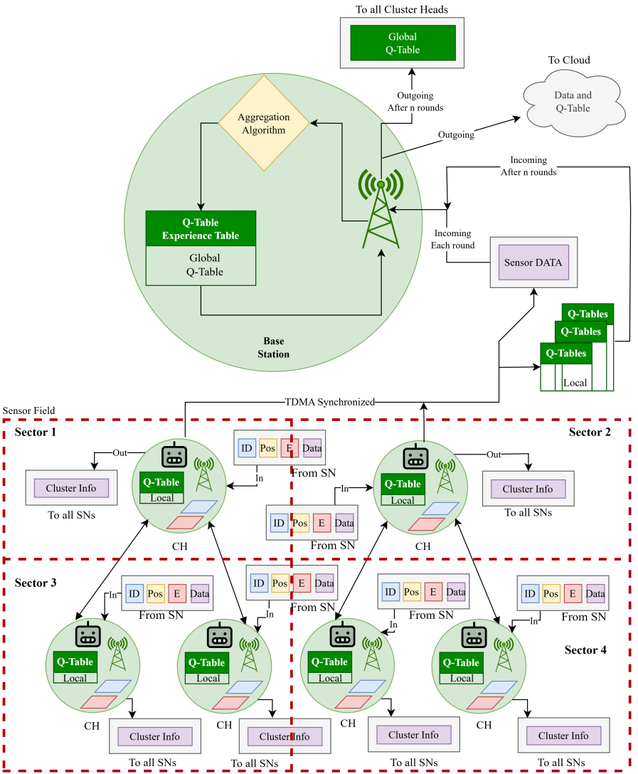
Figure 4.6.2 Federated RLHC Deployment

Results from the simulation indicate that the Federated RLHC format provides Local Learning Agents with a greater ability to survive in the various sectors over time and to exist for longer periods of time than the Centralized approach provides. The distributed nature of the learning format also provides for a balanced amount of energy used by the Local Learning Agents for packet delivery and for continuing to provide reliable packet delivery performance.

The proposed pipeline, formed by combining DEECP candidate selection with spatial optimization (EEKA) and compact clustering (K-Means) as well as adaptive reinforcement learning and realistic communication modeling, produces a closed loop system with constantly optimizing capabilities. This closes the feedback loop on the promise of global optimization provided by the centralized structure and the promise of robustness, scalability and enduring energy efficiency provided by the federated learning model, making it a particularly favourable structure for the provision of safety and security critical monitoring systems for use in underground systems.
Chapter 5

Experimental Setup
The experimental setup defines the simulation environment, network configuration, energy model, learning parameters and evaluation metrics used to analyze the performance of the proposed framework. The objective of this setup is to make sure that fair comparison between baseline clustering protocols and the proposed reinforcement learning based hybrid clustering approach under identical operating conditions.

In simulation each protocol is executed over multiple rounds until termination conditions are reached. The randomness is controlled using consistent initialization to maintain reproducibility. During execution, statistics such as alive nodes, energy consumption, cluster stability and packet delivery performance are recorded at every round. The collected results are subsequently analyzed and compared in the Analysis and Discussion section.

Table 5.1 Network Parameters
Network Parameters | Value
WSN area size | 1000m x 1000m
Initial energy | 2 Joules
Number of Sensor Nodes | 150
Packet size | 128 bytes (1024 bits)
Data aggregation energy | 5n J/bit/signal
Transmit energy | 50n J/bit
Receive energy | 50n J/bit
Free space loss | 10n J/bit
Multipath loss | 0.0013p J/bit
Base Station Mobility | Fixed
Network Type | Heterogeneous WSN
Simulation Rounds | 1000-4000

Table 5.2 Node and Sink Model
Node and Sink Model | Value
Node Mobility | Random Walk
Maximum Node Speed | 1 m/s
Sectorization | 3 × 3 grid (9 sectors)
Operating Frequency | 865 MHz (LoRa)
Channel Type | Composite channel

Chapter 6

Analysis and Discussions

The performance of the proposed RLHC framework is analyzed in terms of network lifetime, energy efficiency, clustering stability, packet delivery performance and adaptability under conditions. The main objective of this analysis is to evaluate the integration of optimization algorithms and conventional clustering approaches as compared to RLHC and observe the performance benchmarks.

6.1 Sector-Wise Survival Analysis
Sector-wise survival analysis evaluates how uniformly nodes remain operational across different regions of the sensing field during network execution. The monitoring area is logically divided into multiple sectors based on spatial coordinates or angular partitioning around the base station. This analysis helps identify energy imbalance, hotspot formation and uneven CH distribution.

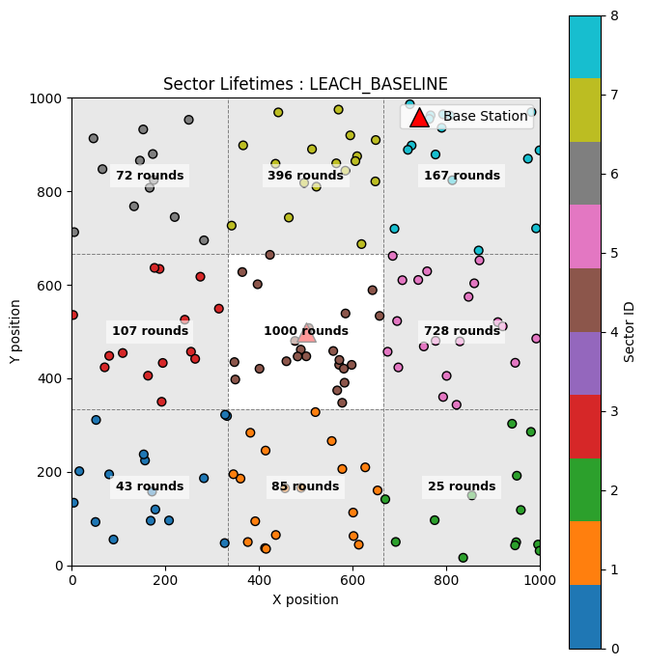
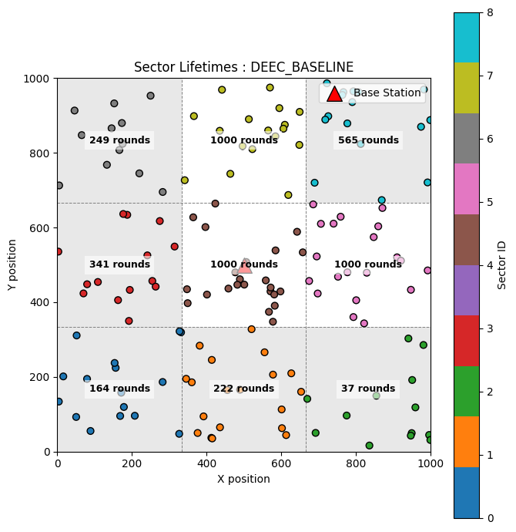

Fig 6.1 Sector-wise survival in LEACH Fig 6.2 Sector-wise survival in DEEC

In the LEACH protocol, CH selection follows a probabilistic rotation mechanism without considering residual energy or node heterogeneity. Each node independently elects itself as a CH based on a predefined threshold probability. Here only 1 out of 9 sector survived.

Whereas DEEC improves sector survivability by incorporating residual energy awareness into CH election. CH probability is proportional to node energy relative to network average energy. High energy nodes assume leadership roles more frequently, reducing overload on weaker nodes. Here only 3 out of 9 sector survived.

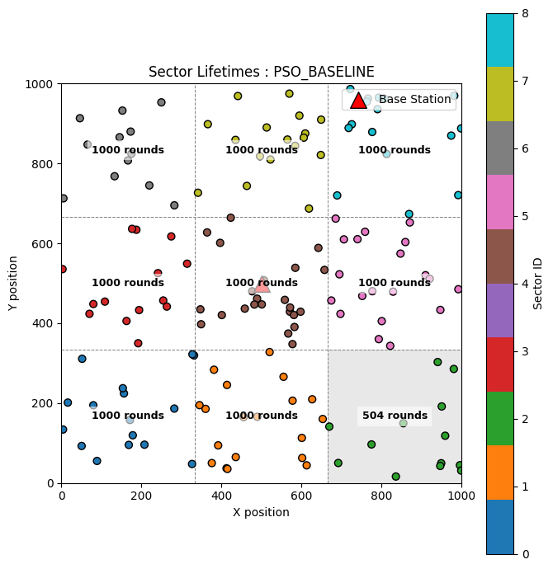
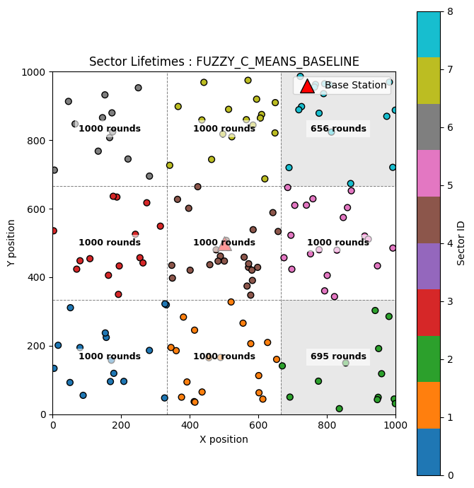

Fig 6.3 Sector-wise survival in FCM Fig 6.4 Sector-wise survival in PSO

In the FCM clustering approach, cluster formation is performed using fuzzy membership functions based primarily on spatial proximity between sensor nodes and cluster centroid. Nodes are assigned to clusters with varying degrees of membership, which improves cluster compactness and reduces intra cluster communication distance. However, CH positioning does not explicitly incorporate residual energy awareness or long-term communication load balancing. As a result CH located in dense sectors experience higher aggregation and forwarding responsibilities. Continuous energy drain in such regions leads to uneven node depletion across the sensing field. Consequently, several sectors experience premature collapse due to localized energy exhaustion. Here 7 out of 9 sectors survived.

In PSO-based clustering protocol is utilized to improve the location and selection of cluster heads using swarming behavior to minimize communication distance and maximize the use of residual energy. The PSO method searches for globally optimal cluster configurations based on both spatial node distribution and energy condition. The adaptive optimization of CH selection prevents the selection of CHs that are adjacent and in energy stressed areas resulting in a more uniform distribution of communication load among sectors. This reduces the formation of hotspot and balances energy consumption over the entire network. The sectors degrade progressively rather than suddenly, giving them a longer period of time with sensing coverage. Out of 9 sectors, there were 8 that survived.
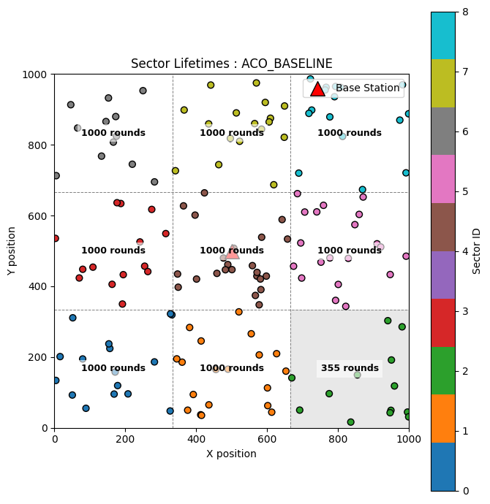
Fig 6.5 Sector-wise survival in ACO

The ACO-based cluster protocol relies on pheromone updating, combined with heuristics of communication distance and remaining energy, to determine CH selection and routing decisions. During the early stages of network operation, ACO distributes CHs quite effectively throughout the sensing field to improve cluster communication distance. Unfortunately, pheromone accumulation is more likely to occur along frequently (successfully) used routing paths and at nodes that are in better locations for communication (centres of clusters and areas with lots of relays). Over successive rounds, these regions may experience repeated selection for aggregation or forwarding tasks, increasing their energy depletion rate.

Although ACO improves routing efficiency and avoids completely random cluster formation, energy imbalance may still develop in sectors responsible for multi-hop forwarding toward the base station. Consequently, some sectors experience earlier node death compared to fully energy-aware optimization schemes. Nevertheless, sector degradation occurs more gradually than probabilistic clustering approaches due to adaptive path exploration.
As a result, sensing coverage is partially preserved across the monitoring area for longer duration compared to simpler protocols. Here 8 out of 9 sectors survived.

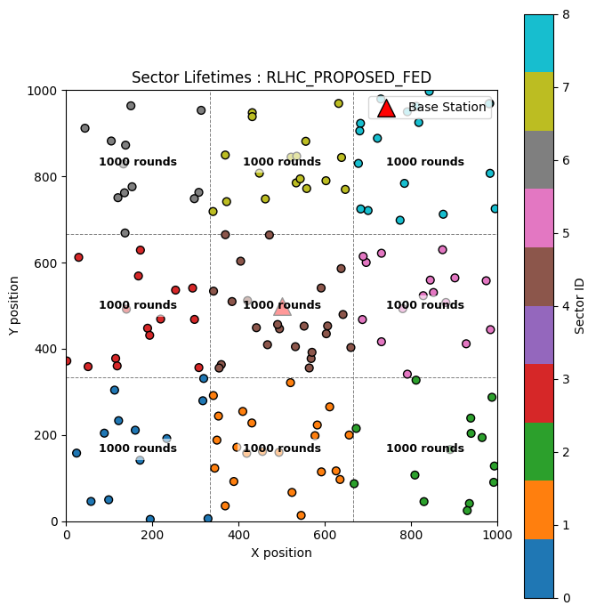
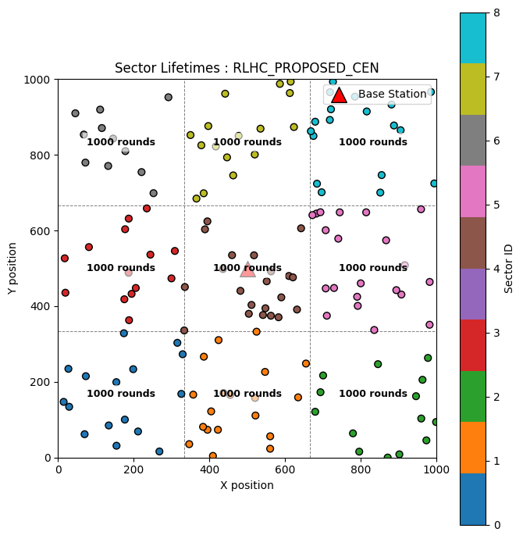

Fig 6.6 Sector-wise survival in RLHC Fig 6.7 Sector-wise survival in RLHC

During early simulation rounds, centralized learning rapidly converges toward optimal decisions because the agent possesses full visibility of node residual energy, cluster load and communication reliability. CHs are selected from energy-rich regions while avoiding excessive concentration within a single sector. This results in uniform cluster formation and reduced early energy depletion. As a result, sensing coverage remains operational in the majority of regions for an extended duration. Here 9 out of 9 sectors survived.

During early operation, local agents adapt rapidly to sector-specific conditions. Since learning occurs near the data source, communication overhead associated with frequent global state transmission is significantly reduced. Energy consumption remains lower compared to centralized learning during coordination phases. Distributed intelligence prevents relay-heavy sectors from becoming long-term bottlenecks for communication. Energy efficiency becomes very even across the networkthe node survival curves are well aligned across all sectors. The federated RLHC continues to exhibit superior robustness as time goes on even if one or more sectors start to degrade, other sectors continue to learn independently and maintain the ability to sense the environment. The collapse of a sector occurs slowly and uniformly across the entire network. Of the 9 total sectors, all have survived.

6.2 Network Lifetime Analysis in Terms of Dead Nodes
As a key performance measure in WSN, the network lifetime is typically evaluated by monitoring how the number of nodes that die off changes as the simulation rounds progress. By conducting a dead node analysis we can gain information regarding the rate of energy dissipation, load balancing capabilities and cluster stability from the different protocols. A node is said to be dead when it has no remaining energy and can no longer participate in sensing, aggregating or communicating.
The lifetime of the network is typically characterized using three major milestones:
- First Node Death (FND) — indicates stability period.
- Half Node Death (HND) — represents network operational reliability.
- Last Node Death (LND) — determines overall lifetime termination.
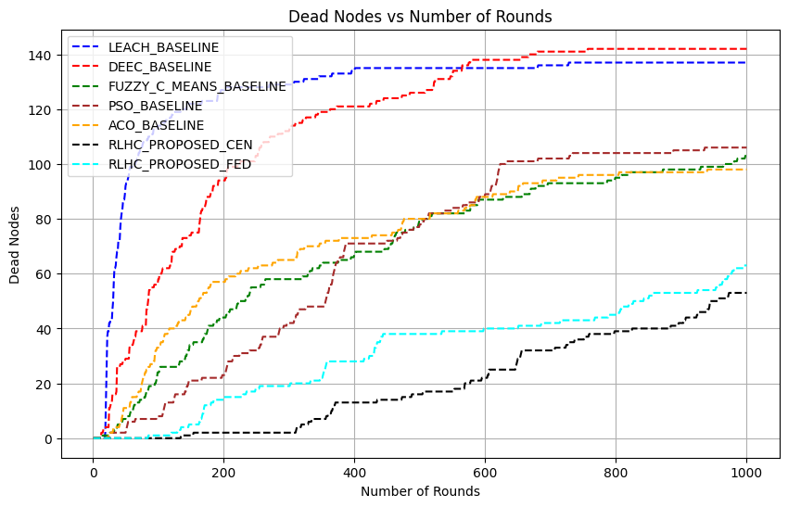
Figure 6.2.1 Network lifetime in terms of node death

Evaluating a network’s lifespan comes down to tracking "dead nodes" sensors that have completely run out of battery. When these nodes fail, the entire system becomes less stable. At the 1,000 simulation mark, older protocols like LEACH and DEEC struggle significantly, losing nearly all 150 nodes because they lack efficient energy management. While optimization techniques like FCM, PSO and ACO fare better by using smarter routing to keep more nodes active, they still can't match the efficiency of RLHC. In the short term, the Centralized RLHC model is the top performer with only 55 dead nodes, as its "big picture" coordination keeps energy use balanced. As the simulation stretches to 4,000 rounds, however, the strengths and weaknesses of these models shift. The Centralized model eventually wears down under the pressure of constant communication with a main hub, leading to 140 dead nodes and leaving only one functional area. In contrast, the Federated RLHC model proves to be the more resilient. By processing data locally and reducing communication overhead, it keeps more nodes alive and maintains three active sectors. Ultimately Federated Learning is the clear winner for keeping a network running for the longer duration.

6.3 Energy Consumption Analysis
Energy consumption directly reflects the efficiency of clustering and communication mechanisms in wireless sensor networks. At 1000 simulation rounds, LEACH and DEEC show the highest energy usage with 297 J and 295 J, respectively, due to random or relay-heavy CH selection leading to rapid energy depletion.
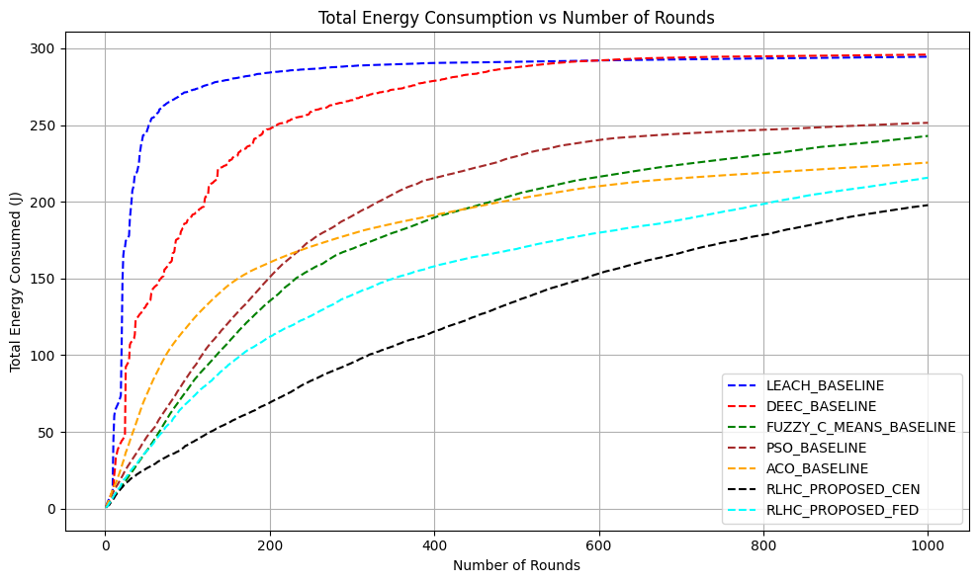
Figure 6.3.1 Total Energy Consumption

Optimization-based approaches demonstrate better performance. FCM consumes 240 J, PSO uses 251 J and ACO further reduces consumption to 220 J through optimized routing and balanced communication load. The proposed RLHC approaches achieve the best efficiency. RLHC Centralized consumes only 197 J, showing maximum short-term energy savings due to global optimization, while RLHC Federated consumes 214 J, maintaining balanced energy utilization with reduced communication overhead.
At 4000 simulation rounds, RLHC Centralized energy consumption increases to 297 J due to continuous coordination overhead, whereas RLHC Federated consumes 286 J, demonstrating better long-term energy sustainability.

Overall, RLHC methods significantly reduce energy consumption compared to conventional and optimization-based protocols, with federated learning providing superior long-term efficiency.

6.4 Throughput Analysis
the total throughput performance of different clustering protocols in terms of successful data transmission to the base station. Throughput represents the amount of useful data delivered per unit time and reflects communication efficiency, cluster stability and routing reliability.
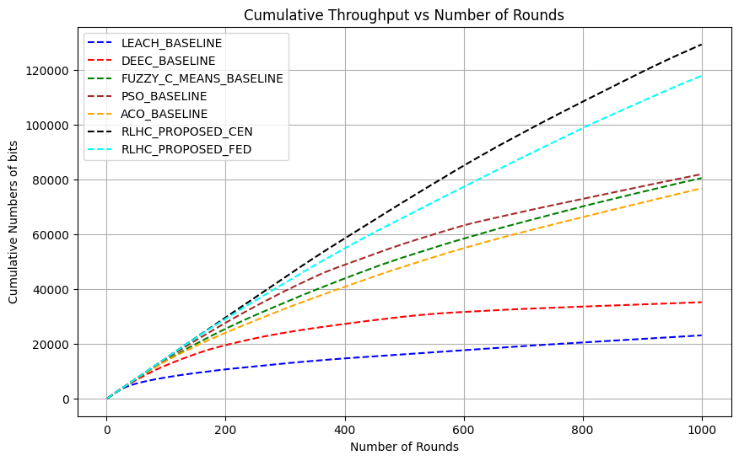
Figure 6.4 Cumulative Throughput

At 1000 simulation rounds, LEACH achieves the lowest throughput of 22 kbps due to random CH selection and frequent packet loss caused by early node failures. DEEC improves performance to 38 kbps by incorporating residual energy awareness, however, relay congestion limits further improvement.
Among optimization-based approaches, FCM achieves 80 kbps, while PSO records 81 kbps, benefiting from compact clustering and optimized CH placement. ACO achieves 77 kbps, where pheromone-guided routing improves link selection but repeated relay usage slightly affects performance. The proposed RLHC approaches demonstrate significant improvement. The RLHC Centralized model achieves the highest throughput of 133 kbps, supported by global decision making and efficient load balancing across clusters. The RLHC Federated model achieves 118 kbps, slightly lower than centralized learning but maintaining stable communication through localized adaptive optimization.
At extended operation of 4000 simulation rounds, throughput increases and RLHC Centralized achieves 260 kbps, while RLHC Federated maintains 250 kbps, demonstrating sustained communication reliability even during late network stages.

Overall, reinforcement learning–based clustering significantly enhances throughput by improving cluster stability, reducing packet loss and optimizing routing decisions compared to conventional and optimization-based protocols

6.5 Result Summary
Table 6.5.1 Comparison table for 1000 rounds of simulation for 150 nodes
Simulation for 1000 rounds
Methods | Sector Survived | No.dead nodes | Energy Usage (J) | Throughput (kbps) | Avg PDR (%)
LEACH | 1/9 | 138/150 | 297/300 | 22 | 99.74
DEEC | 3/9 | 142/150 | 295/300 | 38 | 99.71
PSO | 8/9 | 108/150 | 251/300 | 81 | 99.74
ACO | 8/9 | 94/150 | 220/300 | 77 | 99.86
FCM | 7/9 | 107/150 | 240/300 | 80 | 99.52
RLHC  Centralized | 9/9 | 55/150 | 197/300 | 133 | 99.92
RLHC  Federated | 9/9 | 62/150 | 214/300 | 118 | 99.95

Table 6.5.2 Comparison table for 4000 rounds of simulation for 150 nodes
Simulation for 4000 rounds
Methods | Sector Survived | No.dead nodes | Energy Usage (J) | Throughput (kbps) | Avg PDR (%)
RLHC  Centralized | 1/9 | 140/150 | 297/300 | 260 | 99.87
RLHC  Federated | 3/9 | 130/150 | 286/300 | 250 | 99.97

The results show that LEACH and DEEC experience faster energy depletion and early node deaths due to inefficient load balancing. FCM, PSO and ACO improve clustering efficiency and network stability. The proposed RLHC approaches achieve the best performance, where RLHC Centralized provides highest throughput and short-term efficiency, while RLHC Federated ensures better sector survivability and longer network lifetime through balanced energy consumption and adaptive learning.
Chapter 7

Conclusion and Future Scope
This research proposed a Reinforcement Learning based Hybrid Clustering (RLHC) framework to address major challenges related to energy efficiency, network lifetime, sector survivability and reliable communication in heterogeneous wireless sensor networks. Conventional clustering protocols such as LEACH and DEEC rely on probabilistic or residual energy–based CH selection, which often leads to hotspot formation, uneven load distribution and premature node failures in large-scale and relay-intensive environments. Optimization-based approaches including FCM, PSO and ACO improve clustering compactness and routing efficiency using intelligent optimization techniques. However, their static decision strategies limit adaptability under dynamic network conditions such as residual energy variation, link degradation and sector-level traffic imbalance.
To overcome these limitations, the proposed RLHC framework integrates energy-aware candidate selection, spatial optimization, compact clustering, reinforcement learning–based adaptive decision making and communication management within a unified end-to-end pipeline. Reinforcement learning enables continuous interaction with the network environment, allowing adaptive CH selection and routing optimization based on network feedback.

7.1 Conclusion
Simulation results for 1000 rounds demonstrated clear performance improvements. LEACH and DEEC showed poor survivability with only 1/9 and 3/9 active sectors, respectively, along with high dead node counts (138 and 142 nodes) and maximum energy consumption (297 J and 295 J). Optimization approaches improved performance, where PSO and ACO maintained 8/9 sectors, FCM sustained 7/9 sectors and reduced dead nodes to the range of 94–108 nodes with energy usage between 220–251 J.
In contrast, RLHC achieved the best overall performance. RLHC Centralized maintained 9/9 sector survivability, reduced dead nodes to 55/150, minimized energy consumption to 197 J and achieved the highest throughput of 133 kbps with 99.92% PDR. RLHC Federated also sustained 9/9 sectors, with 62 dead nodes, 214 J energy usage, 118 kbps throughput and the highest reliability of 99.95% PDR, demonstrating balanced long-term stability.
Extended simulations for 4000 rounds further highlighted long-term behaviour. RLHC Centralized retained only 1/9 surviving sector with 140 dead nodes and 297 J energy usage, indicating faster exhaustion under prolonged operation despite high throughput (260 kbps). In comparison, RLHC Federated maintained 3/9 sectors, fewer dead nodes (130/150), lower energy consumption (286 J), sustained high throughput (250 kbps) and superior reliability (99.97% PDR), confirming improved scalability and long-duration robustness.

Overall, the RLHC framework successfully combines deterministic optimization with adaptive reinforcement learning intelligence to achieve balanced energy utilization, improved sector survivability, extended network lifetime and enhanced communication reliability. The federated learning configuration particularly demonstrates strong suitability for large-scale, long-duration deployments such as underground mining monitoring, smart infrastructure surveillance and industrial IoT environments.

7.2 Future Scope
Future work can focus on improving the scalability of RLHC for large-scale wireless sensor networks through distributed and multi-agent reinforcement learning to reduce coordination overhead. Integration of deep reinforcement learning and graph-based learning models may further enhance adaptive CH selection and routing decisions under dynamic network conditions. Energy harvesting–aware clustering can also be incorporated to extend operational lifetime in long-term monitoring applications.
Real-world validation using IoT edge hardware and deployment in applications such as underground mining monitoring, smart infrastructure and industrial environments remains an important direction. Additionally, future research may include security-aware learning mechanisms for fault tolerance and integration with emerging technologies such as UAV assisted data collection and next-generation communication networks to enable fully autonomous intelligent network management.

REFERENCES
- Online Data Source: Directorate General of Mines Safety (DGMS) https://www.dgms.gov.in

- Online Data Source: https://www.assocham.org/uploads/files/Study_Indian%20Mineral%202022.pdf

- S. Saha, S. C. Bakshi, A. Pramanik and R. Lakshmanan, "On Underground Coal Mine Environment Monitoring with LoRa Range Extension," 2023 5th International Conference on Energy, Power and Environment: Towards Flexible Green Energy Technologies (ICEPE), Shillong, India, 2023,1-6, doi: 10.1109/ICEPE57949.2023.10201552

- S. Saha, S. C. Bakshi, A. Pramanik and R. Lakshmanan, "On Underground Coal Mine Environment Monitoring with LoRa Range Extension," 2023 5th International Conference on Energy, Power and Environment: Towards Flexible Green Energy Technologies (ICEPE), Shillong, India, 2023,1-6, doi: 10.1109/ICEPE57949.2023.10201552

- M. Amanzadeh, S. M. Aminossadati, M. S. Kizil, E. Sheridan and W. P. Bowen, "A microfabricated fibre optic sensor for methane gas measurement in underground coal mines," 2012 Photonics Global Conference (PGC), Singapore, 2012, pp. 1-5, doi: 10.1109/PGC.2012.6457999

- Zhang, Y., Wang, J., Han, D. (2021). Energy-Efficient Clustering Routing Protocol Based on Weight for WSN in Coal Mine. IEEE Access, https://doi.org/10.1109/ACCESS.2021.3051200

- Li, P., Xu, Z., & Cui, L. (2021). WSN Coverage Optimization in Coal Mine Based on Improved Whale Optimization Algorithm. IEEE Sensors Journal, https://doi.org/10.1109/JSEN.2021.3074500

- Wang, L., & Liu, X. (2021). A Hybrid Energy-Efficient Routing Protocol for Underground Coal Mine Monitoring. Wireless Personal Communications, https://doi.org/10.1007/s11277-021-08521-x

- Chen, H., Wu, F., & Li, S. (2022). Research on Energy Balanced Routing Strategy for Coal Mine WSN based on Mobile Sink. International Journal of Distributed Sensor Networks, https://doi.org/10.1177/155014772210800

- Ahmadreza Entezari, (2019) Coverage and rate analysis in cellular networks with Nakagami-Lognormal fading channel ISSN 1874-4907,https://doi.org/10.1016/j.phycom.2019.100757. Sciencedirect article

- Kumar, S., & Pal, A. (2022). Fuzzy Logic Based Clustering Algorithm for WSN in Underground Mines. Applied Soft Computing, https://doi.org/10.1016/j.asoc.2022.108500

- B. R. Al-Kaseem, Z. K. Taha, S. W. Abdulmajeedand H. S. Al-Raweshidy, “Optimized energy–efficient path planning strategy in WSN with multiple mobile sinks,” IEEE Access, vol. 9, pp. 79994–80007, Jun. 2021, doi: 10.1109/ACCESS.2021.3087086

- R. Alsaqour, E. S. Ali, R. A. Mokhtar, R. A. Saeed, H. Alhumyaniand M. Abdelhaq, “Efficient energy mechanism in heterogeneous WSNs for underground mining monitoring applications,” IEEE Access, vol. 10, pp. 100123–100138, Jul. 2022, doi: 10.1109/ACCESS.2022.3188654.

- F. M. Salman, A. A. Mohammedand A. F. Mutar, “Optimization of LEACH protocol for WSNs in terms of energy efficiency and network lifetime,” Journal of Cyber Security and Mobility, IEEE vol. 12, no. 3, pp. 275–296, May 2023, doi: 10.13052/jcsm2245-1439.1232.

- M. Gamal, N. E. Mekky, H. H. Solimanand N. A. Hikal, “Enhancing the lifetime of wireless sensor networks using fuzzy logic LEACH technique-based particle swarm optimization,” IEEE Access, vol. 10, pp. 36935–36948, Mar. 2022, doi: 10.1109/ACCESS.2022.3163254.

- S. Mohapatra, P. K. Behera, P. K. Sahoo, S. K. Bisoy “Mobility induced multi-hop LEACH protocol in heterogeneous mobile network,” IEEE Access, vol. 10, pp. 132895–132907, Dec. 2022, doi: 10.1109/ACCESS.2022.3228576.

- Zhao, T., Liu, M., & Zhang, R. (2022). Relay Node Placement in Underground Mines using Genetic Algorithm. IEEE Internet of Things Journal, https://doi.org/10.1109/JIOT.2022.3160000

- Liu, J., Wang, Q., & Zhang, B. (2023). Improved Grey Wolf Optimizer (GWO) for 3D Node Coverage in Mines. Measurement, https://doi.org/10.1016/j.measurement.2023.112500

- Adnan, N., Ali, M., & Khan, S. (2021). LoRa-based Wireless Underground Sensor Networks: Evaluation and Deployment. IEEE Sensors Letters, https://doi.org/10.1109/LSENS.2021.3090000

- Wu, C., Zhang, Y., & Li, H. (2023). Fault-Tolerant Routing Mechanism for Underground Coal Mine WSN. Ad Hoc Networks, https://doi.org/10.1016/j.adhoc.2023.103000

- Zhang, Y., Wang, J., Han, D. (2021). Energy-Efficient Clustering Routing Protocol Based on Weight for WSN in Coal Mine. IEEE Access, https://doi.org/10.1109/ACCESS.2021.3051200
- Bibi, R., Khan, A., & Ahmad, I. (2024). Energy Harvesting WSN Routing Protocol for Underground Applications. Sustainable Energy Technologies and Assessments, https://doi.org/10.1016/j.seta.2024.103500

- Abose, T. A., Tekulapally, V., Kejela, D. C., Megersa, K. T., Daka, S. T., & Jember, K. A. (2024). “Optimized Cluster Routing Protocol With Energy-Sustainable Mechanisms for Wireless Sensor Networks.” IEEE Access, 12, 99661-99671. doi:10.1109/ACCESS.2024.3429645

- Chowdhury, A. R., Bakshi, S. C., Pramanik, A., & Roy, G. C. (2024). “Design and Study of LoRa-Based IIoT Network for Underground Coal Mine Environment.” IEEE Access. DOI: 10.1109/ACCESS.2024

- Abdul Aleem & Rajesh Thumma “Optimizing Energy Efficiency in IoT-Enabled Wireless Sensor Networks Using an Integrated EEKA-K-means Approach” by EEE Sensors Journal, 2025. DOI: 10.1109/JSEN.2025.3582381

- Chaudhari, A., Deshpande (2025). Energy-efficient Q-learning-based routing in wireless sensor networks. International Journal on Smart Sensing and Intelligent Systems, https://doi.org/10.2478/ijssis-2025-0008

- Yang, K., Zhou, Y., & Ma, L. (2023). Dynamic Duty Cycling Scheme for Underground Mine Disaster Monitoring. Process Safety and Environmental Protection, https://doi.org/10.1016/j.psep.2023.01.020

- Singh, P., & Sharma, A. (2023). Deep Reinforcement Learning (DRL) for Routing in Underground Mine WSN. Expert Systems with Applications, https://doi.org/10.1016/j.eswa.2023.119800

- Ahmed, M., & Gani, A. (2021). Cross-Layer Optimization for Video Transmission in Underground Mines. IEEE Transactions on Multimedia, https://doi.org/10.1109/TMM.2021.3060000

- Gupta, S., & Jha, R. (2023). Trust-Based Secure Routing for WSN in IoT-Enabled Mining. IEEE Internet of Things Magazine, IEEE Sensors Journa https://doi.org/10.1109/IOTM.2023.3240000

- Ren, L., Zhang, L., & Wang, L. (2024). Digital Twin-Assisted WSN Performance Optimization in Underground Mines. Journal of Manufacturing Systems, https://doi.org/10.1016/j.jmsy.2024.01.010

- Patel, D., & Shah, P. (2022). Compressive Sensing Data Aggregation for Underground Mines. Physical Communication, IEEE Sensors Journa https://doi.org/10.1016/j.phycom.2022.101800

- Xu, Y., & Hu, X. (2023). Heterogeneous WSN Clustering using Improved Sparrow Search Algorithm. ISA Transactions, https://doi.org/10.1016/j.isatra.2023.05.005

- Seong Ki Yoo (2016) Shadowed Fading in Indoor Off-Body Communication Channels using the κ−μ/Gamma Composite Fading Model IEEE transaction on wireless communication

